Methods and Materials for One Particularly Effective Lesson I Created
(for Monday, October 26, 2015)

I chose this particular day as an example because it shows how I scaffold learning opportunities, use texts, promote invention and prewriting activities, and encourage collaboration and peer review. It also shows an assignment I like because it stretches composition students to communicate and consider communication in ways they have not done before as well as helps them explore their identities and their roles in various communities.

Course: English 250 H
English 250 is the second of two required composition classes at Iowa State University. This is an honors section of the course. I chose to teach this course with a Writing about Writing approach using the following two books:

Wardle, Elizabeth, and Downs, Doug. Writing About Writing. 2nd ed. Boston: Bedford/St. Martin’s, 2014.
Lunsford, Andrea. The Everyday Writer, 5th edition. Boston: Bedford/St. Martin’s, 2013.

In order to contextualize the lesson, I here include a screenshot taken from our English department learning management system, Moodle. For Monday, October 26, the students see two assignments, which I assign and discuss during the previous class: they need to read Branick’s essay and bring a box or folder of texts.

These two assignments fill a scaffolding role for the ethnography research assignment assigned on Monday, October 19. (I have included this assignment following my lesson plan.) When I introduced the assignment I defined the concept of discourse community, discussed the qualitative and quantitative research methods the students could be using, and provided them with two examples of ethnographies previous students had produced for this class and given me permission to share. On Friday, October 23, the students had an opportunity to help each other brainstorm about potential topics for their projects.

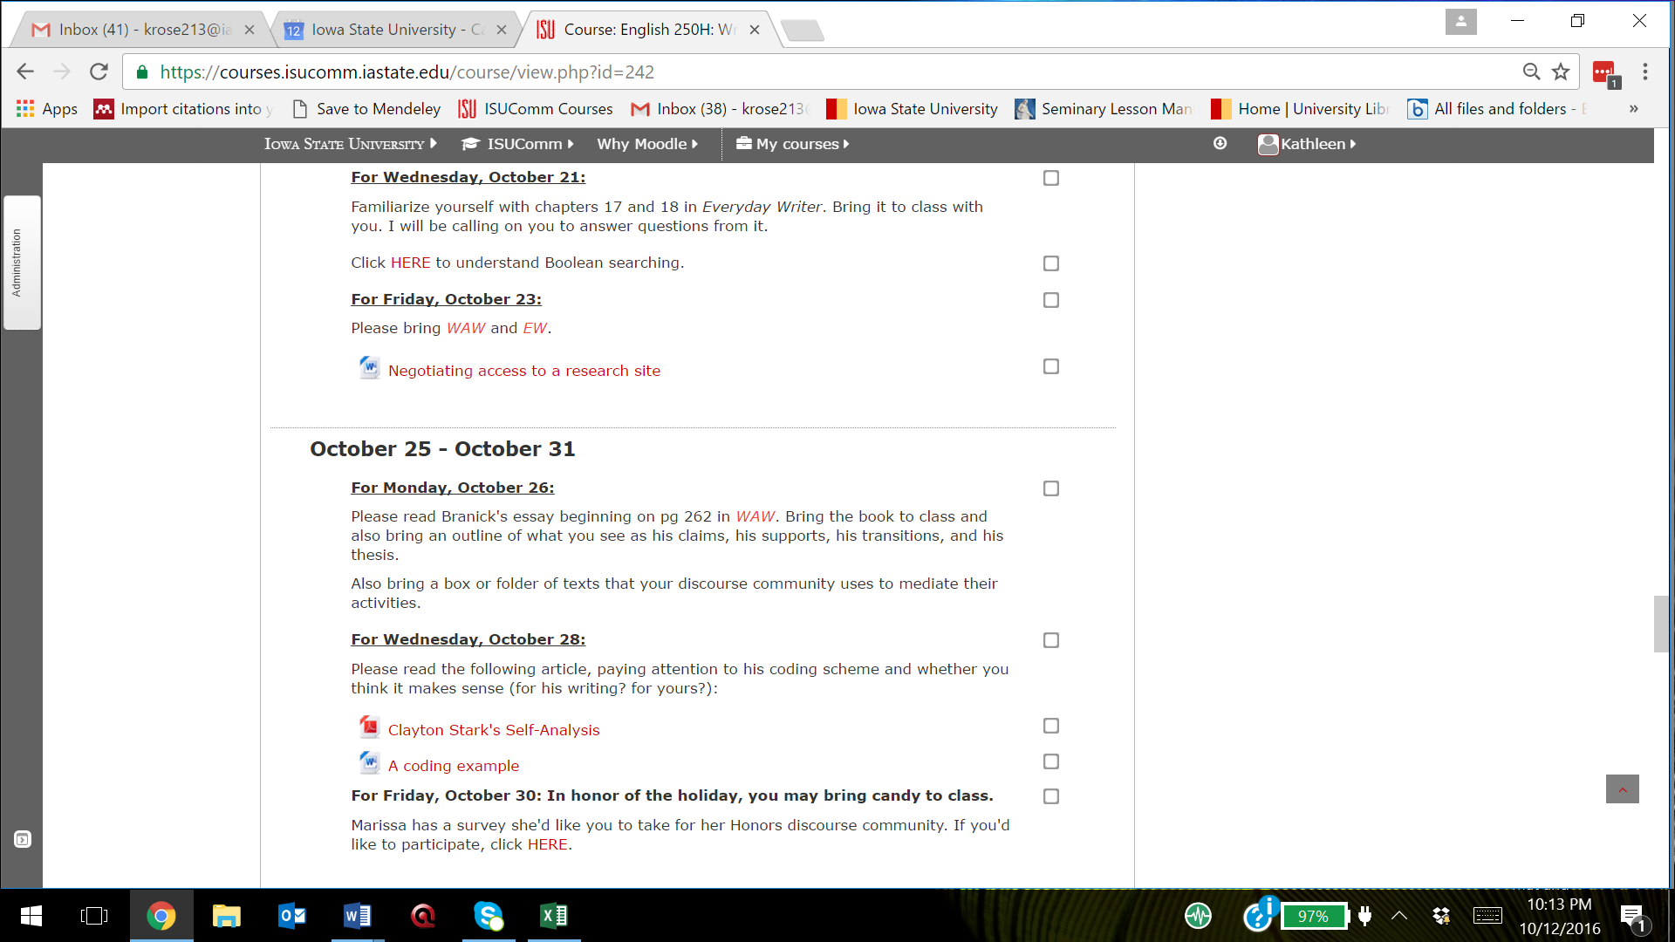
Lesson Plan
Objectives:
(Sean Branick was a freshman when he wrote “Coaches Can Read, Too: An Ethnographic Study of a Football Coaching Discourse Community” for a composition class. It is published in the Wardle and Downs text and is an example of the type of ethnography my students were tackling.)

Upon reading and discussing this article, students will
- recognize that communication and literacy expand to areas like coaches who “read” their players and who know how to read and teach football plays
- be able to identify organizational characteristics of claims, supports, transitions, and thesis statements
- see and discuss the methods Branick used to answer his research questions
- see that undergraduate students like Branick can write publishable work
Upon presenting their broadly defined collection of texts (such as playbooks, flowcharts, music, journals, screenshots of websites or emails, ballet shoes, etc.), students will
- show the results of their non-alphabetic brainstorming exercise
- practice and become more comfortable with informal group presentation skills
- identify a discourse community and their place in it
Because of the question and answer portion of the presentation, students will
- better understand how to effectively talk about their discourse community’s modes of communication
- recognize whether there are modes of communication their discourse community uses that they have not considered
- practice giving and receiving critical feedback
- see the range of topics others have considered
- affirm that their choice of topic is the one they want to pursue, or they will realize that they need to choose another topic
Motivation (~10 Min):
- What were your overall impressions of the Branick article?
- What did you find surprising or interesting?
- Let’s look at the section of his article where he discusses his methods and decide whether these methods were the best way to answer his research questions
Book activity (~10 min):
- I will divide the class into groups of four and have them circle their desks so they can all see each other well.
- Students will compare the outlines they created from reading the article to see what the main points of the article were and how Branick presented them. They can adjust their outlines if they see points others have made that they would like to include on theirs.
- I will circulate and ask each group to show me an example of an effective transition from the article, making sure to draw their attention to subheadings Branick used.
Presentation activity (~20 min):
- Students will take turns showing their group members their collection of “texts,” describing how each represents a mode of communication in their discourse community and also describing how effectively the community uses these modes.
- After everyone has presented, each group will have time to ask questions of each other and offer feedback about choices of texts and suggest other texts that might be interesting to consider
- If there’s time, I will ask students to share with the whole class what they thought most interesting about some of the presentations and choices of text. If not, or if we begin a productive discussion and it needs to be cut short, I will revisit this opportunity during the next class.
Closure (~5 min):
- This activity should have helped you determine whether your choice of topics is one you can explore and write about in detail
- It is time to make a final decision about a topic
- Make sure to get your interviews set up and your research methods chosen (remember to review the document “Negotiating Access to the Interview Site” from Friday’s class)
- Reading assignment for the next class is about how one student coded his qualitative research
Assessment:
- I will ask students to turn in their outlines as part of their participation grade.
- During large and small group discussions I will informally assess how well they understand the reading and the objectives of the day.
- During the presentations I will circulate and informally assess how confident the students are in the communication modes of their discourse communities and in their beginning attempts to analyze the effectiveness of those modes and the leadership/expertise of community members who use them.

Ethnography Research Assignment: Paper and Formal Presentation

Objectives: You will
- conduct a qualitative research project
- investigate a particular discourse community
- say something interesting about how a community communicates
- exhibit good secondary research skills
- synthesize a variety of sources

Invention/Prewriting activities you will participate in:
- In-class lists about discourse communities of which you are a member
- Answers to questions on pp 555 and 573
- Dialogue you created: a pretend conversation that could happen in your discourse community if an “outsider” wants to become an “insider”
- Email to me about which discourse community you intend to research and how it fits into the six characteristics Swales lists
- Presentation about box of stuff (this is a box [or envelope] of items that represent your discourse community. It should include three-dimensional items as well as anything that people in the community read or write (their genres).
- Attend a conference with me where you show me your rough draft
- Observation and interview notes and/or recordings

Rough draft of ONLY secondary research section due x/xx

Rough draft of entire paper due during our conference on x/xx

Final paper due x/xx

Presentations will be 5-7 minutes each (please time yourself and do not go over 8 minutes), on x/xx,. Presentations will be accompanied by (but not taken over by) some sort of visual
(PowerPoint, Prezi, poster, movie, etc.). I will give you a separate assignment sheet and rubric
for the presentation.

Choose a discourse community that has impacted you or one that interests you, and find a preliminary answer to this research question: “What are the goals and characteristics of this discourse community?” After analyzing your data, refine the research question to fit your particular interest in this study.

Data Collection:

Primary Research:

Observe members of the discourse community while they are engaged in a shared activity; take detailed notes. Record them with permission, if you can.
- What are they doing?
- What kinds of things do they say?
- What do they write? What do they read?
- How do you know who is “in” and who is “out”? How hard is it to become an insider?
- Do you see any authority or identity issues?

Interview at least one member of the discourse community. Use Swales’s 6 characteristics to guide your questions. You might ask things like
- How long have you been here?
- Why are you involved?
- What do X, Y, and Z words mean?
- How did you learn to write A, B, or C?
- How do you communicate with other people [on your team, at your restaurant, etc]?

Describe anything about the setting, the clothing, or the nonverbal actions of the participants that you think is relevant or would add to the context of your discussion.
With permission, collect anything people in that community read or write, even very short communications like forms, sketches, notes, IMs and text messages.
If you wish, you may administer a survey.

Secondary Research:

What is a discourse community?
We have discussed discourse communities. Use your WAW book as a source in the section of your paper where you set up the context for your study and discuss how your discourse community works. (Refer to specific pages.)

What do scholars say about your subject?
Find at least two scholarly sources which discuss, in general, the type of community you are looking at. Scholarly means peer-reviewed, like from an academic journal.

What do other people say about your subject?
Use at least one other type of source like from a website, magazine, YouTube video, documentary, NPR report, etc., to give background about your particular topic.

Data Analysis:

- Read through your notes and the documents of the discourse community. Listen to anything you may have recorded. Notice recurring themes or issues that might be interesting to form a hypothesis about. Create a coding scheme if it helps your analysis.
- Decide what you would like to quote in your paper as examples of these recurring themes or issues. How can you generalize what you have seen/heard/experienced for this particular group at this particular time? What can you say that will build knowledge about the way communication works for this group in particular and about people in general? How does your work fill a niche that might be interesting to students of language or interactions?

Examples of themes or issues (feel free to create your own as long as it relates to communication):
(Do not answer all of these! Choose a narrow focus for your research question!)
- Is this a well-functioning community, or are there breakdowns in communications, drama in the relationships, or goals that do not get achieved as fully as the community needs in order to function well? Ask yourself why or why not.
- How do experienced members of the community use communication genres to enculturate inexperienced members?
- How accessible are the genres of this community to newcomers? Are they aware of how accessible they are or are not?
- What function does their lexis perform? (that is, why use lingo that no one else understands?)
- Are there communication improvements you could suggest in order to help this community function better or achieve its goals more fully? Do they take full advantage of the potential of the Web?
- Can you suggest a new genre based on your observations of this community and how it communicates?
- Are members of this community stereotyped in any way based on how they communicate or the lexis that they use? Why?

Planning or drafting:

- Begin with a very brief review of the existing literature (published research) on the topic (“We know X about discourse communities” [cite authors from chapter 2 of WAW, as appropriate]).
- Define your particular subject and develop context for your discussion with other secondary resources.
- Name a niche (“But we don’t know Y” or “No one has looked at X”).
- Explain how you will occupy the niche (your thesis: “This study shows that…”).
- Describe your research methods. Include how many participants you observed, interviewed, and/or surveyed and what you did to accurately record their actions and perceptions as you explored your research question.
- Discuss your findings in detail (use the authors we have read as examples of how to do this—quote from your notes, your interview, the texts you collected, and so on).
- Include a references page.
- Your audience is a scholarly audience of people interested in how language works. Consider developing this project to become a presentation at an undergraduate conference or an article in an undergraduate journal.
- Your paper should use headings and transitions in a top-down approach to signal to the reader where one topic ends and another begins.

Rubric for Ethnography Assignment

Prewriting:
- A list of Swales' characteristics of a d c and how your choice fits those characteristics--3 pts
- Observation, survey, and interview notes and/or recordings--10 pts
- Rough draft of secondary research (includes a. a scholar-based discussion of what a discourse community is, b. at least two scholarly, peer reviewed sources about your topic, c. at least one other source about your topic, and d. synthesizes all secondary sources together in a smooth way that supports and gives context to what you will say about your particular discourse community.)—5 pts.
- Rough draft of entire paper—5 pts.
- Your responses to your peers about their drafts—8 pts

Final paper:
Context: this is where you lay the foundation so that your audience will understand how this group of people actually form a discourse community, pertinent background information about them, and why you chose it—16 pts
- Thorough discussion about what a discourse community is, using secondary source materials
- Thorough discussion about the type of community you researched, using secondary source materials
- Your discussion should include definitions for any lexis that is not common knowledge for people on the outside of this discourse community
- You introduce your research as filling a gap no one has ever discussed in quite this way before
Substance: mostly in sections called something like “Methods” and/or “Results”—18 pts
- Thorough description of your research methods, the numbers and types of participants you researched, and your position in relation to this community
- You include substantial detail in the form of information you gained by observing the community, as well as specific quotes from participants and their various genres of communication
- You discuss patterns you found as you analyzed the data, as well as people who did not seem to fit the patterns (they do not all need to fit; in fact, people don’t categorize easily)
Organization: look at the articles we read in WAW for examples of headings—15 pts
- Your layout of the different sections of your paper is clear, logical, and easy to follow because of both transitional sentences and subheadings
- Your thesis reveals the results of your research early in the paper
- Each paragraph has one main idea
- Conclusion effectively summarizes your main ideas and discusses why what you have discovered with your research is important
Style: here’s where you show your professional ethos—10 pts
- Your visual is well integrated into the text (both labelled and referred to) in a space that makes sense to the meaning of your document and adds to your research in a way that words alone would not
- Correct grammar and usage conventions
Delivery: use your Everyday Writer to find information about citing interviews, etc.—10 pts
- Paper format should accurately follow the style you choose (tell me if it’s not MLA or APA)
- Correct paraphrasing and quotations
- Correct in-text citations and references page

Rubric for Oral Presentation

Note: we developed this rubric in class during a discussion or best practices in presentations. I asked a student to take notes while we brainstormed for the criteria, and I left the words the way she recorded them)

Context—12 points
- Strong intro-hook (fun fact or question or quote or story)
- Explain background to audience (what is your community all about)
- Tell research question
- Talk about Methods of research
- LAY IT OUT—what you’re going to talk about and in what order
- Why!?! this research is important
Substance—12 points
- Describe research A LOT
- Examples
- NOT all secondary research—just make connections
- Leave out definition of discourse community-slit throats
- Need visual (depends on length—videos have good impact but take time)
Organization—12 points
- Top down approach
- Conclusion: recap, closure, any questions
- DO NOT SAY “Sooo yaaaa”
- Cueing devices- “first I’m going to talk about this..move to that” (verbally shift)
Style—12 points
- Good volume level and…dynamics!! Enthusiastic!
- CONSISTENCY with fonts and colors and wotes lol
- Good contrast with colors (dark and light background)
- 14 font is as small as you want to go
- Well prepared and practiced “YEAH BUDDY”
- Clear and concise
- Few words on ppt slides
Delivery—
12 points
- NO READING OFF PAPER!!
- Eye contact with EVERYONE
- Do not talk too fast
- No UMSS or LIKEE
- No awkward hands
- No pacing or rocking

Invention/Prewriting—turn these in as you give your presentation

Check out the “Tufte reading”—10 points
The first page has “Using Visual Aids in a Presentation,” “Rehearsing your Presentation,” and “Guidelines for Evaluating Oral Presentations” for you to review.
The next page is an article by Edward Tufte, an expert in visual rhetoric. He has some strong opinions about PowerPoint presentations!
- Read his article and write an outline of his main points. How does he feel about PowerPoint presentations and why? You have the advantage (or disadvantage!) of my annotations in this scanned copy.
- Describe what is wrong with the PowerPoint slides on page 576.

Your rhetorical choices—10 points
- Talk about the visual choices you made. How will your choices help your audience understand your message? If a visual is supposed to augment a message, how should yours do that?
- Talk about your visual choices from a design aspect. (Discuss pattern, contrast, direction, chunking, and color.)

Your feedback for other presenters—we’ll work on this during presentations—20 points
- For all presenters, talk about things you liked about their presentation of their information and what their visual looked like (style and delivery).
- Do you think an outsider can understand from this presentation what this discourse community is really like? Or are there unanswered questions an outsider might have?
- In your own words, write for the presenter what you think his or her research question is and how well the study answered that question. If you were to suggest more primary research to make this study more complete, what would it be?

