Aye Nu Win

Professor Terrill

ENG 250

10 March 2017

Arjuna’s Yoga Advertisement

The “*Arjuna Yoga Centre: Woman*” advertisement was created by RA Voskhod advertising agency. This piece of advertisement was illustrated by a Russian illustrator, Oksana Grivina and was released in September of 2012 (Lixil Graphics, 2012). My analysis of this advertisement will focus briefly on the artist’s use of color and the main subject in the center of the image. While the illustration alone was done by Grivina, it required several contributors for it to become a decent piece of advertisement such as creative director, art director, designer, and an illustrator herself. The ultimate goal of this illustration is to emphasize the benefit of practicing yoga to women in their early and middle adulthood which is becoming stress free.

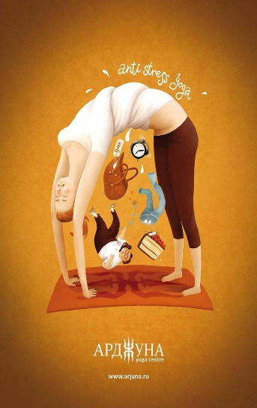The use of colors that put together into the illustration is very effective because they don’t distract the audience from its main focus which is the woman. The corners of the image contain darker brown and lightened into russet orange as they are pushing in toward the core of the image. The woman’s hair color and skin tone, the orange rug, and the articles that are falling away from her middle body part complimented each other because they each contain some brown and orange elements. The pale skin tone made the core of the image more stood out and easy to follow. The two colors of brown and russet orange elements display a soothing mood to incorporate the idea that when practicing yoga, you will feel relaxed.

Fig. 1 “Arjuna Yoga Centre: Woman,” illustrated by Oksana Grivina

The subject matter in the center of the vertical layout illustration is a flexible cartoon woman with exaggerated body figure demonstrating a yoga pose. The designer added a very interesting visual effect to the middle part of the woman’s body, a twist you would get from wringing out a cloth. I negotiated the twist to wringing out a cloth because of the white droplets above the twist and some falling away from it as dripping water. The water droplets represent the weight that the woman has had to carry with her that led to her stressful life. It is trying to convince its audience that if you were to practice yoga, it will take away all your problems and heavy weight that your mind and body is carrying from stressing out so much.

The articles which are falling away from her body between her arms and legs are factors that produce the woman’s stress. The advertising agency chose to include main factors that women can most likely relate to. Articles include a manual clock, a price-tagged purse, a cheesecake, a pair of “L” labeled jeans, and suited man. The manual clock is a sign of poor time management or not having enough time to accomplish things that need to be done. The price-tagged purse represents the stress she experiences over financial issues and not being able to afford material that she desires. A “L” labeled jeans represents the stress she experiences with finding the right size when shopping for clothing. The cheesecake represents a poor diet and lastly, the suited man represents a boss whom she works under.

Each article represents a specific problem to this woman’s life which shows that the advertising agency is using pathos, or emotional appeals to convince its argument. For an example, the price-tagged purse appeals to emotion because if you were to walk into a store and not able to afford the product that you desire will create emotions and this illustration did very well with corresponding women’s typical insolences. However, the agency left many other factors out that can cause stress. I thought that it was also biased because not every woman’s stress come from not being able to afford purses or some interested in expensive materials like that at all. It is dishonorable that the agency is representing women as whom stress over their body image by including the “L” size jeans to indicate that wearing a large size is a source of stress for women. In the contrary, I liked that the agency chose a woman figure that appears in her early or middle adulthood in the illustration. According to American Psychological Association, “women are 8 percent more stressed than men” and in ages between eighteen to thirty-three (APA, 2017).

In conclusion, this piece of advertisement is very effective due to its inclusion of the stereotypical women’s everyday issues. The ad is effective in reaching out women in their early and middle adulthood and who are middle classes by socioeconomic status. This generalized causes of stress and the advertising agency is trying to convince its audience that yoga will alleviate your stress from all the factors: poor time management, financial issues, struggles to find the right clothes, poor diet, and working under a boss.

Works Cited

Ahmed, Faisal, and Jawaid. “50 Fresh Examples of Advertising Posters” *Graphic Design Junction*. WordPress, 09 June 2010. Web. 03 March 2017

<<http://graphicdesignjunction.com/2012/09/50-fresh-examples-of-advertising-posters/>>.

Coloribus. “Arjuna yoga centre:Woman” *Lixil Graphics Ltd*, 2012. Web. 30 Mar. 2017. <https://www.coloribus.com/adsarchive/prints/arjuna-yoga-centre-man-15912955/>.

American Psychological Association. “Stress by Generation.” Web. 31 Mar. 2017.

< http://www.apa.org/support/index.aspx/>