Arline Votruba

Dr. New

Pop Culture

March 12, 2016

How Pop Culture Informs Ideologies

We are constantly being fed advertisements, now more than ever. Our consumer based culture turns common interactions into commercial affairs. We sit down to lunch with friends at the Zorn and are face-to-face with napkin holders, ads on both sides. When you ride a public train or shuttle there are signs telling you to upgrade your cellular service or to finally sign up for online dating. At the gas station, a screen plays clips from *The Tonight Show,* right on the pump, as you fill your tank. We are constantly being fed commercials.

As a millennial, I have grown up completely surrounded by these sources of ‘information’ always trying to sway my view in one direction or the other. While we recognize actual commercials and advertisements as selling us ideas, we easily forget to question the entertainment we engage in. Tracing connections between a show I watch on Netflix, back to vaudeville performances from the 1890s, helped me to understand the ways that popular culture, specifically theater or acting performances, has a major influence on societal ideologies.

In Chelsea Handler’s *Chelsea Does* series on Netflix, episode three addresses racism. Just after a scene where Chelsea’s father categorizes various races of people as liars, she interviews Reverand Al Sharpton, a civil rights leader. She juxtaposes the ignorant comments by her father with a private interview where she asks Sharpton what he thinks about racism. She asks whether Sharpton thought of racism as being hardwired, learned, or if people are born racist. He says, “I think people, are born, maybe, noticing differences. I may know I’m different than the guy next to me, but somebody has to tell me that I am better than him and that he shouldn’t have the same life,” (Chelsea Does Racism 5:03). This statement is a very logical approach to understanding racism. Of course we can tell that people have different skin tones, but it takes someone teaching us that the color of a person’s skin distinguishes their status to create racist views. While racist ideologies are taught, it is also possible to reject what people are trying to teach. I think that Chelsea recognizes the platform she has in entertainment and does a lot to critique outdated ideologies like racism. *Chelsea Does* just reached Netflix in 2016 but the struggle of racism on American soil dates back to before The United States of America was even a country. Racism has been in entertainment for centuries. During the 1880s, actors destroyed reputations through vaudeville performances, until vaudeville fizzled out as a primary source of entertainment in America during the early 1930s.

In Leroy Ashby’s *With Amusement For All*, a history of American pop culture since 1830, he describes the very origins of white people in America using people of *non-white* ancestry as characters in mainstream entertainment. Vaudeville was derived from the French expression “City Voice”, which explains their appeal to audiences. At the time, vaudeville shows would have been depicted as diverse and culturally riveting variety shows. The primarily white middle class audience was being shown very negative portrayals of people from Indian, Mexican, Irish, Jewish, African and many other lines of ancestry, that had immigrated to the U.S. around that time and found work as vaudeville performers (Wikipedia). The use of stereotyping within these performances then trickled into the mainstream ideologies of the audience. This cycle of absorbing the messages of entertainment seems obvious when imagining it happening in the past, but we are susceptible to the same kind of unconscious learning now. This means that if we are to move away from racism, we must not casually engage with racism like in films, TV and literature, without calling it out.

Portraying people of other ethnic groups in prejudiced caricatures had been done before, but in the 1890’s, with the rise of vaudeville shows, came a new venue through which people could spread their hateful ideologies. White men such as B.F. Keith, a vaudeville theater owner; E.F. Albee II, a vaudeville impresario; and Alexander Pantages, vaudevillian, are known for their powerful positions within vaudevillian productions, (Wikipedia). These men organized the shows and took advantage of those entertainers by deliberately choosing to feature acts that negatively portrayed other races. Not cool.

Considering this history, it is clear that the mainstream middle class population, which was mostly white, would attend these performances where as Ashby says the vaudevillians, “endured such treatment and isolation because they viewed the stage as a ladder of economic and social mobility,” (WAFA 122). The men who organized vaudevillian entertainment controlled the messages being expressed to audiences, who were enthralled by the show. In other words, vaudevillian entertainment was the equivalent of Netflix binge watching in the 1890s, and the only things streaming were blatantly racist. The immigrant vaudevillians probably thought that performing in America would allot them the opportunity to prosper, seeing through the American dream to full fruition. Instead, white men in power took advantage of their positions and depicted other races in harmful ways in order to keep them in their marginalized position. I’m here to argue that some of the most interesting bits of life are written in the margins.

Analyzing literature from the era can help to understand the conversation regarding race at the time. In W.E.B. DuBois 1903 publication, *The Souls of Black Folk*, he writes, “...the full, complete Negro message of the whole Negro Race has not as yet been given to the world,” and continues by adding in other misrepresented peoples, “...the messages and ideal of the yellow race have not been completed, and that the striving of the mighty Slavs has but begun.”(183) DuBois was a civil rights activist, a prominant figure in the movement to abolish racism, and here he confronts the issue of untold stories. He promotes the idea that although there is no changing the past, “if the Negro is ever to be a factor in the world’s history- if among the gaily- colored banners that deck the broad ramparts of civilization is to hang one uncompromising black, then it must be placed there by black hands,” (183). I agree with DuBois. Each person deserves to tell their own story, and generalizing groups of people is detrimental to everyone. With the control of traveling acts lying in the hands of rich white men, it was impossible for the marginalized groups to defend their name if they intended to perform on these vaudeville stages. It is important for us to consider in modern television, whether the portrayal of people of other races are intended to make us think lowly of them.

Following the trend of attending vaudeville shows, came other performances that emerged from the minstrel tradition. In *Negro Character as Seen by White Authors*, Sterling A. Brown critiques some of the views expressed in Roark Bradford’s writing. Bradford wrote *Ol’ Man Adam an’ His Chillun*, later adapted into a play written by Marc Connelly (Brown 179). The play won a Pilitzer Prize for Drama in 1930, just around the time that vaudeville was phasing out because plays like Connelly’s *Green Pastures,* offer incomplete characterizations of people that audiences adapt as stereotypes. Just the description on the Wikipedia page emanates the essence of the present racism that plagues our society. Wikipedia says that the play is comprised of episodes from the *Old Testament*. It was written by a white author who sets the play in the Depression-era South, told through the eyes of a young African-American. The African-American child, “interprets *The Bible* in terms familiar to her.” This sounds like glossing over the negative characterization of this girl within the play. This play, written based on an all-black context by a white author, was imagined rather than researched. This was one instance of a racially charged inaccurate depiction of black people.

Brown writes, “Mr. Bradford’s stories remain highly amusing; his generalizations about *the* Negro remain a far better analysis of a white man than of *the* Negro,” (179). His criticism is relevant to my own encounters with modern racists. I work at Charlie’s Diner in Spencer, Massachusetts. The old 1950’s cart diner I started at when I was 16 features a sign, “This is a diner atmosphere, we are not politically correct.” Recently, I was greeted to a Trump sign hanging by the register as I entered for my shift. As a group 40-50-year-old men were discussing politics at the counter, a man referred to Obama as, “the black one.” Clearly people still dehumanize black people by categorizing them in such general terms. Like Bradford, this man was generalizing in a way that depicted his narrow minded view more than the image of who he was describing. Although I have worked at the diner for years, I have only recently noticed these micro aggressions during work hours, likely due to the combination of literature I have been reading for classes. This emphasizes my point that racism can be learned, and unlearned.

Keeping historical pop culture references fresh in mind, I consider my own exposure to black people. The show *Gullah Gullah Island* aired from 1994-1998. Born in 1995, I remember this as being my first favorite television show. The show was an American musical. The children’s series aired on Nickelodeon as part of an initiative to broaden preschool programming and starred Ron and Natalie Daise. As it turns out, Ron and Natalie were cultural advisors and the show was inspired by the culture of St. Helena Island, South Carolina, part of the Sea Islands and Daise’s home. Ron Daise said of creating the show based on an existing culture, “We wanted to make sure the portrayal was positive and didn't in any way poke fun at the culture or the community," (Wikipedia). It is really interesting to think that a century following the use of minstrelsy by white people “portraying” black people, there was an opportunity for black people to streamline on national television. Its devastating, however, that as the first show of its kind to star an African-American family, they had to worry about the way that they recreated the image of black people. The past pop culture leading to that moment added to the pressures of creating the show, whereas shows featuring white families are aired frequently. My exposure to this show as a child certainly allowed me to perceive race on my own terms and I think that it was beneficial in teaching me about people from different parts of the world.

Tracing the emergence of mainstream ideologies through pop culture allows us to see the generational differences as well as the generational consistencies of American culture. Considering my early experiences of exposure to people of other races allowed me to link the popular culture of the 1890s to my own life, as a 1990s baby. In doing so, I have recognized the impact of entertainment and mass media on societal ideologies. We should always be critical of the things we engage in as entertainment, because those things all have messages and often those messages are detrimental to marginalized groups. If we recognize the patterns of our past history, we can move forward in creating new images, just images, of people, who represent themselves. If we assess the problems provoked by hateful ideologies, we can move forward as people, toward a society that is beneficial to all. We must stop teaching people that some humans deserve more than others, wasting time creating false images of people we don’t even know, and instead ban together as a human race to battle the global problems that threaten us all.

Works Cited

Ashby, LeRoy. With Amusement for All: A History of American Popular Culture Since 1830.

Lexington: University Press of Kentucky, 2006. Print.

Brown, Sterling A. "Negro Character as Seen by White Authors." *The Journal of Negro Education*

2.2 (1933): 179. Web.

Du Bois, W. E. B.. Souls of Black Folk. Oxford, GBR: Oxford University Press, UK, 2007. ProQuest

ebrary. Web. 14 February 2016.Copyright © 2007. Oxford University Press, UK. All rights

reserved.

Wikipedia contributors. "Vaudeville." *Wikipedia, The Free Encyclopedia*. Wikipedia, The Free

Encyclopedia, 8 Mar. 2016. Web. 13 Mar. 2016.

Wikipedia contributors. "Gullah Gullah Island." *Wikipedia, The Free Encyclopedia*. Wikipedia,

The Free Encyclopedia, 10 Mar. 2016. Web. 13 Mar. 2016.

Additional notes and text to expand overall thesis:

We can (must) refuse the outdated ideologies of our elders by rejecting popular culture that negatively stigmatizes marginalized groups.

“While most vaudeville performers came from impoverished backgrounds, they were typically also social outsiders and representatives of marginalized groups,” (WAFA 122).

In crowded cities, “vaudeville’s wordplay, full of malapropisms and verbal misunderstandings, resonated with immigrants who were trying to learn a new language,” (WAFA 123). It seems quite possible that during such comedic acts, words might be misconstrued and the actors look unintelligent or comical rather than as recently arrived in this new country- demonstrates the early stages of stereotypes.

“Stage stereotypes could, indeed, reflect outright bigotry, insensitivity, and ignorance of diverse ethnic and racial groups,” (WAFA 124). The text explains that using demeaning portraits of people sometimes led native-born Americans to reaffirm feelings of superiority over new immigrants through laughing at the caricatures at the ethnic group’s expense.

“For some white performers, blackface offered opportunities that may not otherwise have existed,” (WAFA 125). Really? It seems off kilter considering it was not until white chicks that black people tried white face (is this true? look up)

“Not surprisingly, as various immigrant groups tried to enhance their positions in American society, they took issue with the unflattering stereotypes,” (WAFA 127).

Ashby brings up the example of Bert Williams, the best-selling black recording artist before 1920, who struggled with the psychological pressure of performing vaudeville as a black person. He writes that black vaudevillians like Williams, “…could enjoy the attention they received onstage, but outside the theater they encountered constant reminders of their inferior status,” (WAFA 127). The actors performed as a means of generating income, however they paid a price of deteriorating their identity

^This example reminds me of seeing The Hateful Eight with my dad.

Ashby explains that although Williams paid a high personal toll by performing in these shows, Booker T. Washington recognized Williams for his achievements, “has done more for the race than I have. He has smiled his way into people’s hearts,” (WAFA 127). This is hearbreaking when considering W.C Fields’ view that Williams was the finniest yet saddest man. Harmful stereotypes create a lowered self-esteem. The image you have of yourself is limited by the way “people like you” are depicted within the entertainment.

It was not just black people that suffered from being misrepresented in performances.

A particular example of the ways popular entertainment reflected the social and cultural norms of the 1890s are the shows where Native Americans performed as Indians. On page 85 Joe Rockboy, an Ihanktonwan-Sicangu Sioux said that performing, “gave me a chance to get back on a horse and act it out again.” This line was devastating. Native Americans had their way of life ripped from them and were then encouraged to act out their old traditions to turn a profit for a white performing group owner. This situation depicts the ways that racism encouraged particular entertainment that in turn reaffirmed racism within the performance itself. It is tricky to comment on what it meant for a Native American to act as their ancestors in a show, because while they might have felt they were contributing to a remembrance ceremony of sorts, they were also strengthening the stereotypes of white people

In W.E.B. Du Bois The Souls of Black Folk, he writes, “The American Negro has always felt an intense personal interest in discussions as to the origins and destinies of races: primarily because back of most discussions of race with which he is familiar, have lurked certain assumptions as to his natural abilities, as to his political, intellectual and moral status, which he felt were wrong”

Perhaps the most legendary myth of the United States of America is “The American Dream”. It has had an incredible impact on the content of popular entertainment in correlation to the hope given to fans at sports games. WAFA talks about stars like Babe Ruth that changed the focus of American entertainment to sports games. Then the success led to manufacturing all kinds of merchandise. It is almost as if the American Dream is to reach a level of success that allows you to feature your face on merchandise. This is how commercialism plays into the values of American society and pop culture. On page 185 Babe Ruth says that, “the greatest thing about this country is the wonderful fact that it doesn’t matter which side of the tracks you were born on, or whether you’re homeless or homely or friendless. The chance is still there. I know.” This quote emphasizes the misconceptions of the American Dream and it reminds me of the limitations people face due to other elements of their identity such as race, gender, or sexuality.

Tapping into the popular culture that I grew up with has better informed me about the ways I relate to the world.

So for me, it is striking that we have to study these things.

At the very bottom of things, giving energy to hate is just a crime against ourselves. Choosing love is effortlessly rewarding.

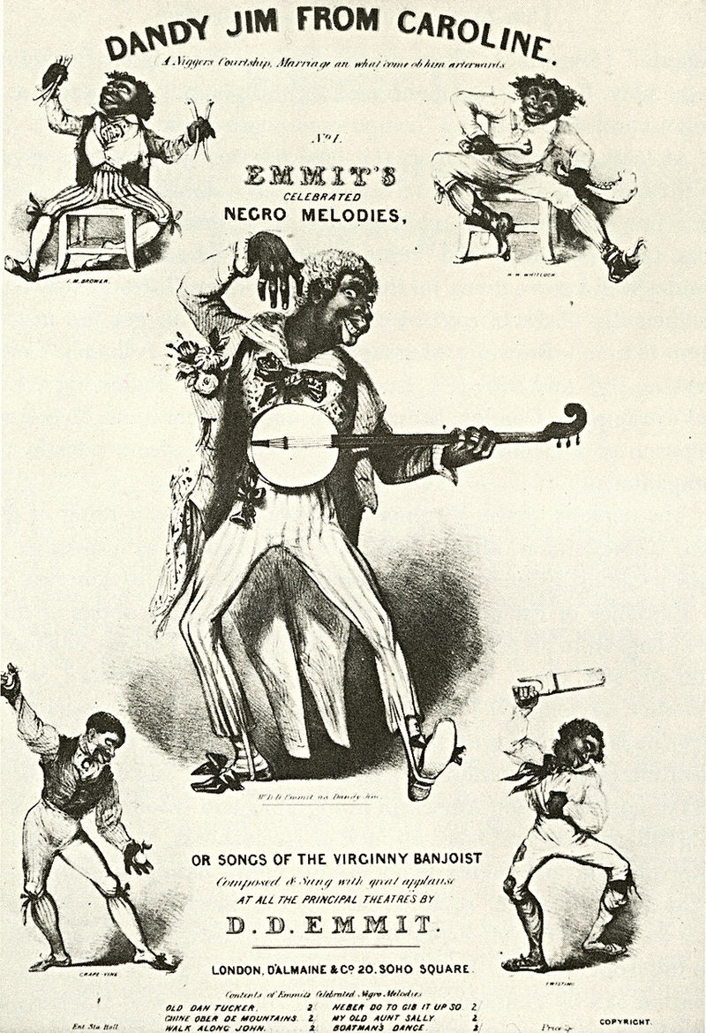Sheet music cover for "Dandy Jim from Caroline", featuring [Dan Emmett](https://en.wikipedia.org/wiki/Dan_Emmett) (center) and the other [Virginia Minstrels](https://en.wikipedia.org/wiki/Virginia_Minstrels), c. 1844 Wikipedia

