ENG308: Experimental Non-Fiction

Final Portfolio

Arline Votruba

Experimental Writing requires innovation in the already imaginative field of creative writing. Combining genres can be tricky, but when done with care, the end result becomes an interesting, multidimensional piece of writing. A complete experimental essay is fueled by the use of multiple genres, focusing on diverse approaches to writing. I took this course to challenge myself by expanding my writer’s toolbox. By incorporating the various approaches to writing we have discussed throughout the semester, I have been able to develop my writing skills substantially. I knew that this class would offer a very contemporary view on writing and it has helped me to expand my techniques beyond traditional narrative or poetry.

As we began reading this semester, I noticed that the pieces were often more interesting than any assigned readings I have been given in college. Soon I was eager to attempt the strategies we read by authors writing multi-genre pieces. I felt inspired to incorporate the strategies used by these authors into my own work. Practicing creative responses actually led me to a new hobby of writing just after reading. Now when I read an interesting piece of literature, regardless of the class, I seek a particular passage that stood out to me. I then write my own piece with the intent of emulating the particular passage and incorporating the writing strategies of that author into my own work as a writing exercise.

I have included in this portfolio an example of a creative response where I attempted to emulate the detailed description of a photo done by Ellen Birkett Morris in “John Birkett.” It was also the first time I used an image in my writing. This toe in the water provoked me to dive in, incorporating visuals in many of the pieces I wrote after that. Pairing this class with a photography class this same semester, I think that I have started to understand the endless possibilities of my future as an author.

One of my personal goals for this class had to do with content. I was determined to open up more in my writing. In the Student Questionnaire I explained that I wanted, “to be fearless with what personal thoughts, feelings, ideas or experiences I share.” I think that I achieved this goal. It is especially evident in the incomplete essay, “The Saga of Olive” where I share explicit details regarding our relationship and our pasts. It hurt to unearth some of the truth in this essay, but putting the words to the page helped me during the time of the events. I think working on the piece actually helped me to speed up the process of coping with the events, and when I finally hit the point that I felt I had exhausted my rants about Olivia, I moved on and started to write a new piece.

The piece “Forget I Said I Love You” is the first completed essay I wrote for this class. It uses a variety of genres such as poetry, lists, narrative, a wanted ad and images to tell the story in a multi-dimensional way. This piece is one I am proud of and chose to include in my final creative writing portfolio as well. The piece is very lyrical and offers a blend of narrative and poetry that moves the story along at a moderate pace.

The last piece I have been working on for this class is Live on Air. It is complete at this point, however I do believe that I will continue to work with it after this class in order to capture the full scope of my radio experience. This piece is very dear to my heart and I am trying my best to document this life experience in a vibrant and interesting way. WKNH has been a very positive aspect of my college experience and I want to capture that in the completed essay. I would like to print a finished copy to leave in the station when I have graduated.

I always hesitate to say that a piece of my writing is “complete.” I find that the more times I read a piece I am working on, more revisions present themselves. That being said, this portfolio offers both pieces in their early stages as well as some pieces that could be considered finished at this point. The scope of pieces I have shared in this portfolio are highly representative of the skills I have developed writing experimental essays throughout the semester.

Forget I Said I Love You

Arline Votruba

* The loss of superior closeness shared between you and your love steals away a piece of you. When that love leaves, so does that portion of your soul that had been unearthed only through the very act of falling into love.
* Only you can seek that fragment of forgotten soul in new places.

On the first day of 7th grade, I entered my first Spanish class. Across the room, I saw the bushy blond curly hair and thick-rimmed glasses of the prepubescent man of my dreams. When it was time to work in groups, he came over to me and sat down. I noticed his Led Zeppelin tee and sparked up a conversation. We talked in class every day. Our friendship flourished with each passing month. We made all kinds of wild plans. He promised me that he would tattoo my name on his behind and I promised him that in old age we could choose death by suicide as we planned to motorcycle naked into the Grand Canyon when we both hit 85-years-old. We brought out the zany in each other. I will never forget how his big blonde curls and crystal blue eyes pulled me in. The next year when he cut his hair, the teacher didn’t even recognize him. I didn’t either. He was becoming a man.

When we finally decided to date it was not as romantic of a chase as I imagined. His geeky awkwardness that I found adorable blinded me to the lameness of our “festering love.” I had fantasized it to be such a perfect love story: Girl meets boy in middle school Spanish, they bat eyes at one another and remain best friends for years. They reunite a year after graduating high school and reminisce. Sparks fly as they exchange words of “I always knew” and “I loved you too.” She graduates college and he gets his performance certificate at New England Conservatory and they travel the world, writing songs and writing stories while they busk from town to town.

In the summer of 2014 I visited Liam in Boston. When I saw him and the ways he had grown since high school I became more interested than ever. We started dating shortly after my first visit to the city.

On a hot July day we loaded the kayaks into the bed of my Dad’s pick up and cruised ten minutes down the road to Brooks Pond. I struggled to carry the giant kayak but refused his offer of help.

As we floated in the water, the wind was the only sound that rustled through my ears aside from the occasional *tap tap* as our kayaks collided.

We paddled around and enjoyed the sweet serenity of nonexistent responsibilities and one another’s company. We would paddle far enough that the view felt new and then we would simply drift where the wind took us. We talked for hours out on the open water, catching up from the many months spent apart at school.

Then, as I ranted about how wonderful this all was, I asked if he had anything to add.

“I love you.”

SPRING BREAK 2014

Pulling into the long dirt driveway, my body bumps and jolts. I finally catch sight of the huge log cabin through the clearing of trees and I park my jeep. The front door opens before I am able to unbuckle.

He hops in the car, “Are you ready?”

“Are YOU ready!?” I notice how much older he looks, his baby face vanished beneath a scruffy beard.

The ride to Northampton was a jukebox of reminiscing- broken record talk about the good old days, “When things were easy.”

“May I help you?” the woman behind the counter has ink across her entire body. She smiles at us with her head cocked. She snaps her gum.

“I am looking to get a butt tattoo- of a name,” He giggles like a kid.

I smile. Here we are, 7 years later, still best friends. He still makes me laugh with his cynicism and I still manage to drag a smile out of him on his worst days.

The buzzing of the needle swarms my ears like mosquitos. We giggle through the pain of his left butt cheek.

Early SUMMER 2014

Nervous to leave

by myself down the tracks

toward the big city-

everywhere I’d been before,

my momma brought me

Public transportation-

people do this daily,

if I ever intend to see the world,

it’s time I overcome any hesitations

of traveling alone,

otherwise

never go any place new

Late for my train-

another will be by soon

Choo-choo

On my way.

**The Proposal**

June 16, 2014 10:55am

I will never forget it. I was visiting a friend in Mystic, Connecticut. It was morning; the sun was out so I sat on her front steps writing in my journal. A blanket of sunrays warmed my bare legs. I was wearing my huge floppy sunhat and scribbling thoughts into my leather bound journal. Liam and I were texting.

Liam: Arline will you marry me? I feel like my life will turn OK, if you stick around.

Me: (: Wasn’t that the plan?

Liam: Just confirming.

**Crossing the Line**

June 17, 2014

I hop on the trampoline and nestle my body into Liam’s side. It feels so nice to finally cuddle in each other’s arms. We stare up into the dark until our eyes adjust. Finally our eyes register the pinholes of starlight spackling the black abyss. Of course, as we share our first real romantic moment, a shooting star soars across the sky.

His face moves close. Our lips touch. And again. He pulls away. A smile that could outshine the sun- our first kiss. Liam speaks softly, “It took long enough, 7 years?”

Serendipity (n): the occurrence and development of events by chance in a happy or beneficial way

My first night visiting Liam in Boston was great. Excitement fluttered through my veins as the train rolled to a stop at Yawkey. Liam came to meet me and we went to his apartment a few blocks away, just around the corner from Fenway. After the grand tour (which took all of 45 seconds in the quaint apartment), we left Liam’s roommate Joseph to do some studying and Liam led me down sidewalks lined with cafés and bookstores. It was much different strolling around the city. Pavement replaced grass, streetlights replaced stars and it was much more congested than the small towns where we had grown up. We were passing a gallery as jazz trickled out into the street. I tugged his arm and led him into the art show. I felt out of place. I was in a flannel, his tee shirt had rips and the jazz band wore button-down shirts with ties. We listened and admired the ambiance of the well-lit gallery as a woman offered us champagne. Unable to present a proper ID, we declined. I remember watching the musicians, thinking how maybe someday I would be able to go see Liam play in a gallery.

“Next stop, Yawkey,” the uniformed train worker was always good like that, reminding me it was time to get going. As I stepped out of the sliding door I could see him standing there, smiling wider than the sky, mirroring my expression. We hugged despite the discomfort of my backpack bulging from behind me. We kissed like it had been years, disregarding the fact that just days before, we had done the same. Giddy as could be, we were floating on each other’s love, the way I always knew it would feel, that is, when I found true love.

That train ride became routine. The hours spent in his apartment, the frequent walks to the Christian Science Center. Hours spent lying tangled up in each other, sharing kisses, laughter, secrets and dreams.

**Sittin’ on the Dock of the Charles**

I can still feel the heat of that summer night in mid-August. The stars hid from me whenever I spent the night in Boston, but I knew they were up there sparkling down. We walked hand-in-hand down to the dock where we liked to sit. The Charles River could not have shimmered any more beautifully. The dock was flooded with young adults, like us, despite the late hour. A couple on the corner had a bottle of wine with two glasses while other groups of friends made circles around the guitar players. We sat, my arm wrapped around his, my head leaning against him. I looked at him, smirked and nibbled his shoulder. He wrinkled his nose back at me and let out a quiet laugh. He loved when I would bite him, even if he pretended otherwise.

SPLASH!

I quickly turned my head to see.

SPLASH! SWOOSH! SPLASH!

Wild spirits tore off their clothes and began jumping off of the dock into the water. Chasing each other in, they hopped into the glistening water and sparkled in the thrill of it all.

“I dare you to jump in,” I said quietly right up against his ear.

He stood up, took off his shoes and handed me his glasses. When he stood close to the edge of the dock, I stopped him, “You better get a running start!”

He stepped back then took off and joined the others who splashed before him.

Watching the smile, the bravery, the joy, I felt myself untying my bright red Chucks, anxious I was not going fast enough.

“Are you jumping in?” My friend Angela asked. I had almost forgotten that we came to the dock to meet up with her and our pal Glenna who had left the party before us.

“You are crazy!” Glenna added.

Disregarding their comments, I soared into the water to be with my favorite person. We soaked our street clothes without concern. We kicked our legs and wiggled our arms, we kissed each other in the river surrounded by strangers who swam in circles singing “One Love” by Bob Marley. When I looked into his eyes, treading water to stay afloat, I could see us as an old couple drinking tea on the porch reminiscing, about “That time when we were young.”

Walking back to his apartment in soggy clothes, I would squeeze his hand, and he would squeeze mine back.

Reasons We Fell in Love:

* those thick framed rectangular glasses
* that birthmark by his mouth
* the dimples when he smiles
* his gorgeous blue eyes
* years of friendship
* his bass-playing skills
* our inability to be too serious together
* our love of star gazing
* when he told me I was beautiful (and I wasn’t wearing any makeup)
* his inability to hush about his opinion
* a mutual need to adventure
* comfortably shared silences
* we kept our promises to each other
* he always made me laugh
* great listener
* his silly cynical rants
* his snoring was cute
* he didn’t pressure me
* his beautiful home
* the effortless flow of our conversation

Scribbled on a random page of my diary:

*He hugs me like a bear and makes me feel tiny. He is so strong and can pick me up no problem. The way he keeps playing with my hair or rubbing my back when I fall asleep assures me that Liam has so much love for me, it is rather a beautiful thing.*

* Post Forever
* Above me a gray cloud labeled You
* cirrostratus clouds hanging high
* like thin sheets
* covering the whole sky-
* threatening to spatter
* a rainy memory
* into the few glimpses
* of bravery I find
* on my best of dreary days.
* You never bring me a storm.
* Rain on me.
* Send the winds
* whipping by
* to sweep
* me again
* off my feet
* and thunder so I can feel you rumbling through my bones.

Before:

When I see you, I see us grown old

Our lives have been shared and stories all told

Each moment we spent together--

Honey, they couldn’t have been any better

No time was wasted I am certainly sure.

Each time I was down, you found me a cure

None other could keep me as safe

No other could look so brave

So until we see the grave

Your soul I will crave

After:

When I see pictures of us, I see love turned to mold

Since we last spoke you’ve been so cold

Those moments we spent together

Are mere memories of a young love

A summer that fell apart

Right from the start

I can hardly tell you

from the friend I couldn’t live without

no interest in rekindling the fire

that you already put out

So until we see the grave

Apologies I will save

Fall 2014

I moved back to school and he stayed in Boston. Although I always awoke in good spirits, there came days when I knew that we would not talk. He did not need to hear my voice the way I needed to hear his. I would scramble around, from workouts with my trainer, to classes, to the dining commons, to the library for homework, to voice lessons, participating in club meetings, and I would always find little moments to send him my love in a text or a call. His frequency of responding plummeted. My desire to clutch my fingertips to a love once effortless was beginning to grow exhausted.

Dear Inner Intuition,

Love seems far away. A knot has replaced the flutter in my tummy that used to light up my days. He doesn’t call when he gets out of work anymore. When I see him he is always tired. Last time he visited me at school, inconveniently during classes, I woke up absurdly early to pick him up an hour away at the train station. The next night I asked whether he was going to stay up with me or if I should drive him back to the station so I wouldn’t have to get up extra early to drive two hours before classes, he said he would stay up. I was hanging up decorations around my dorm when he started snoring. When I got up early to bring him back to the train station, he promised that he would stay awake for the drive. He failed at that too, complaining that he felt sick. There is no longer a spark. I feel like I am watching him instead of being with him. What should I do?

Sincerely,

Lost Lonely Lover

Dear Lost Lonely Lover,

You already know.

Best of luck,

Inner Intuition

*ARLINE hangs her arms over the railing and stares down at the water below.*

*LIAM: [steps closer to ARLINE]* Is everything okay? You have never been this quiet.

ARLINE: I have never run out of things to say, not to you at least. When this all started things were so great. [LIAM looks down] Lately you have not been the man I fell in love with. You have neglected to keep our communication going. You forget to call me, never mind compliment me or reassure me. Where did you go? Why did you stop trying? I can’t see where this can go when I feel I chase you down to simply say hello. The spark that lit up my world just weeks ago is a cold pile of ash. I am sorry, but I am not happy. I can’t be here. I can’t do this. I do love you and it breaks my own heart to have to say these words to you, but you gave up on us just like everything else.

Edit Profile CLICK

Family and Relationships CLICK

Edit CLICK

Single GULP

Save Changes CLICK

We solemnly announce the passing of a very young Love. Sometime in the early weeks of October 2014 Arline took the life of her romantic relationship on the bridge of Otter Brook Dam in Keene, NH. Just 3 months old, Love leaves behind dreams of turning into a lifetime. In her brief life here on Earth, Love was able to travel around Boston on hot summer days in the form of hand holding between her kin, Arline and Liam, who have not communicated since her passing. Love leaves behind many happy hours spent roaming the sticky city streets of Boston in July, nights of star gazing in the New England countryside of central Massachusetts, and hopes of going on to explore Europe as a unit. Love took with her his virginity. Although Love was a fighter, she was unable to persevere through the early weeks of a new semester as Arline began class again at Keene State. Love, although surely missed, is left behind with her closest kin at peace now understanding that she shall no longer suffer.

Ex-love-of-my-life,

Thank you for showing me that I deserve better

Thank you for leaving me with your comfy sweater

I’m sad that you let it get to this

I’m sad you clocked out when life got too hectic

You missed my show, time and time again

After promising so often that you would tune in

On top of it all you borrowed lots of money

I’m still waiting on my payback, honey

Of course there are days when I miss your face

and walking barefoot to our secret place

overlooking the river, the city, the chance

remembering all your silly little rants

You tickled me with sweet nothings,

Squeezed my hand to tell me something,

then one day when I was at school

you forgot all the things boyfriends ought to do

You no longer break my heart. The endless chatter of unspoken words swirling about my head has finally been typed and sent. I am awaiting a response that will never come. Your silence, my answer to move on.

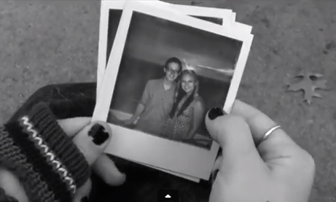

I co-produced this corny video ‘Your Hand in Mine’ for a video production class. The video is online at https://www.youtube.com/watch?v=Jgozrtu4ULc and was created shortly after Liam and I broke up.

I broke up with him.

I stole his heart

and when I gave it back

tattered and worn

there were too many pieces

to reassemble.

Our love a delicate bloom

broken by summer days

spent walking hand in hand

along the busy Boston streets

or curled together under a tree

tracing the tattoo on his arm with my finger

sometimes outlining his neck with my lips

pretending that

we

would last more than a season

I told him without words.

He heard in my silence

the door to my heart

sliding to a close

and he could not muster

the courage to knock the door in

Outside the realm of us

outside the possibility

that this was just

a mere miscommunication.

I left him,

though I wish I never

had to make that choice.

Reasons we fell out of love:

* he was lazy
* he smoked too many cigarettes
* he thought his opinion was always right
* he forgot to call
* he broke promises
* he stopped playing bass
* he stopped playing with my hair
* he snores
* he stopped holding my hand
* he was always tired

WANTED

One true love. Requires an unending kind of attraction that is much more than just physical. Respect and fidelity required. Conversationalist preferred. Beards encouraged. Must be committed to a lifetime. Applicants must have a job, a valid driver’s license, and a working cellular phone. Female applicants will not be considered.

& then there was none

The very love that sent me soaring to the moon

alongside the glimmering constellations of stars

by a string tied to a celestial balloon

and guided me throughout space

for week-long trances,

soon popped against a star’s edge.

This tumbled me from the grave black sky

limp, my body rocketed down towards Earth

SPLASH!

& then that once love

sparkled in the reflection

of the Charles river,

where we had swam,

kicking off our shoes, wearing our street clothes

that time we jumped in after each other

in the middle of that hot summer night-

I forget who dared who.

The sweet words that used to make me weak

now worth nothing more than a cringe

of a memory long since lived

ever since the day I moved away.

Never previously pursued,

in a pursuit of perfect timing,

this trip to space did not last.

Soon I was trapped

twisting an old brass key to unlock the door

that led me into a room

lined with shelves

covered by unopened boxes

labeled “chance.”

I stepped forward to realize

entering that room alone

is better than to walk in

followed by a shadow.

*

Silence is my secret weapon-

slicing away the pleasant view

we once saw standing in this place.

We overlook the water

that this mountain of rock dams

and stops from washing away

the road by which we got here.

Gazing at the bushels

of deep greens, reds, oranges, some yellow

seeing perhaps the same beautiful forest scene

but our minds

our hearts

disconnected long before I drove us

to the place you would soon regard

as the place our love drowned.

Afterword

Although it hurts that our friendship of 7 years vaporized into the atmosphere of “newly single,” I have managed to press on. Sure, I miss his friendship, but I have tried to reach out and he has yet to say a word back. On the day that I broke up with him, he just sat there quietly. The only thing he took time to vocalize was, “Good luck finding somebody who loves you as much as I do.” At first, it was shocking. I was fearful that I might have walked away from the real deal. Over time, it became clear to me that if he truly loved me the way he argued, he would never have left without trying to convince me that our relationship was worth working for. He gave up. He gave up the way I watched him do so many times in his life. I never thought he would give up on me but he did- the first day he forgot to tell me that he loved me. After a long time spent moping around with a brick in my chest where my heart used to be, I realized that I had done the right thing. I had not given up on Liam. It was he who gave up on himself. Our breakup taught me a lot about the way people change. It taught me that it is important not to hold onto a memory of a person, instead you must see them for who they are today.

Live on Air by Arline Votruba



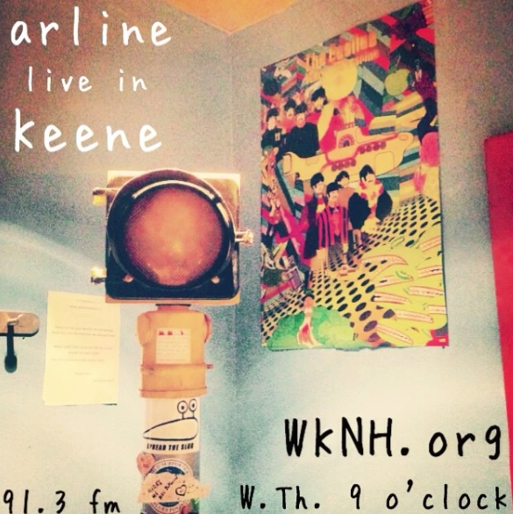There is a place hidden in the back corner of the Keene State College Student Center where practicing radio hosts go to unleash the soundtracks of their lives. Up the stairs to the third floor, to the right of the Mountain View Room, follow the hall towards the sign to The Equinox, our college newspaper. Walk towards that sign and hang a hard right- there in big letters is W-K-N-H. The sign hangs above a cozy couch. The door requires a code that only WKNH hosts are given. Punch in the lucky five digits and enter a music lover’s haven. The black walls are splatter-painted with neon greens, blues and oranges. In the lobby of the station is a squishy dark green couch beneath a bulletin board pinned with newspaper articles such as a song review of “Roll Me Under” by Joeannan I had published in The Equinox. There are newspaper clippings of WKNH members from years passed as well as posters advertising current shows. All WKNH members are welcome to hang up artwork, posters, articles or newspaper clippings.

The station is a truly artistic space encouraging to any aspiring radio host.

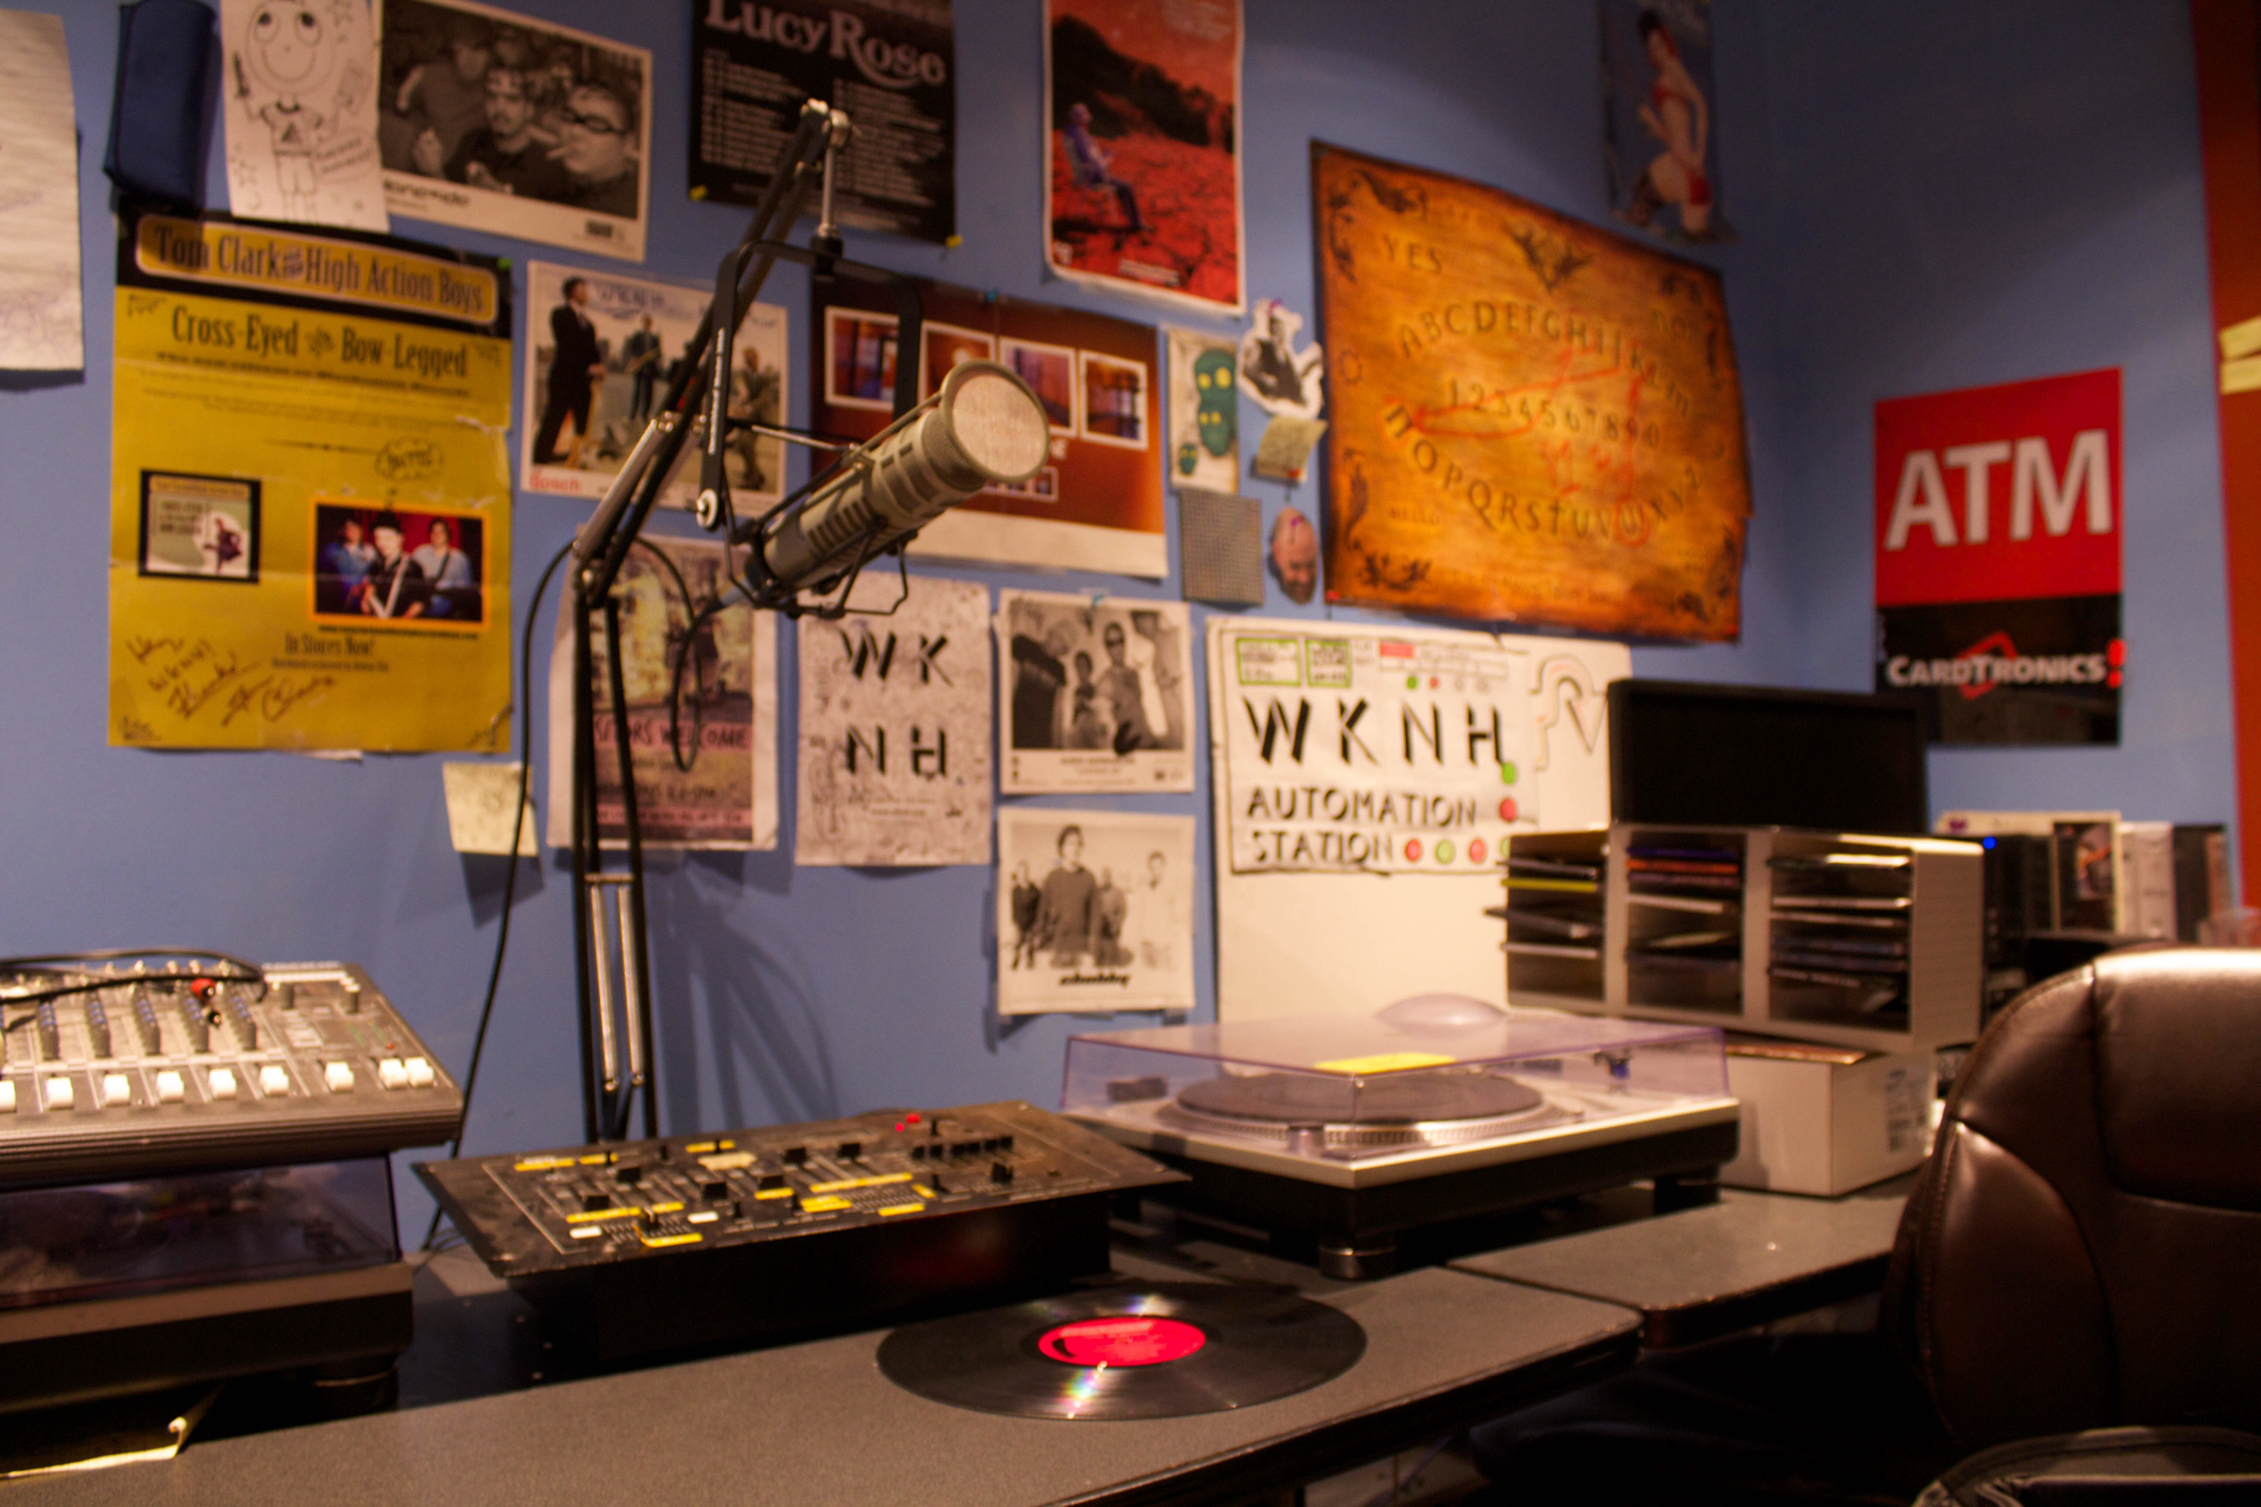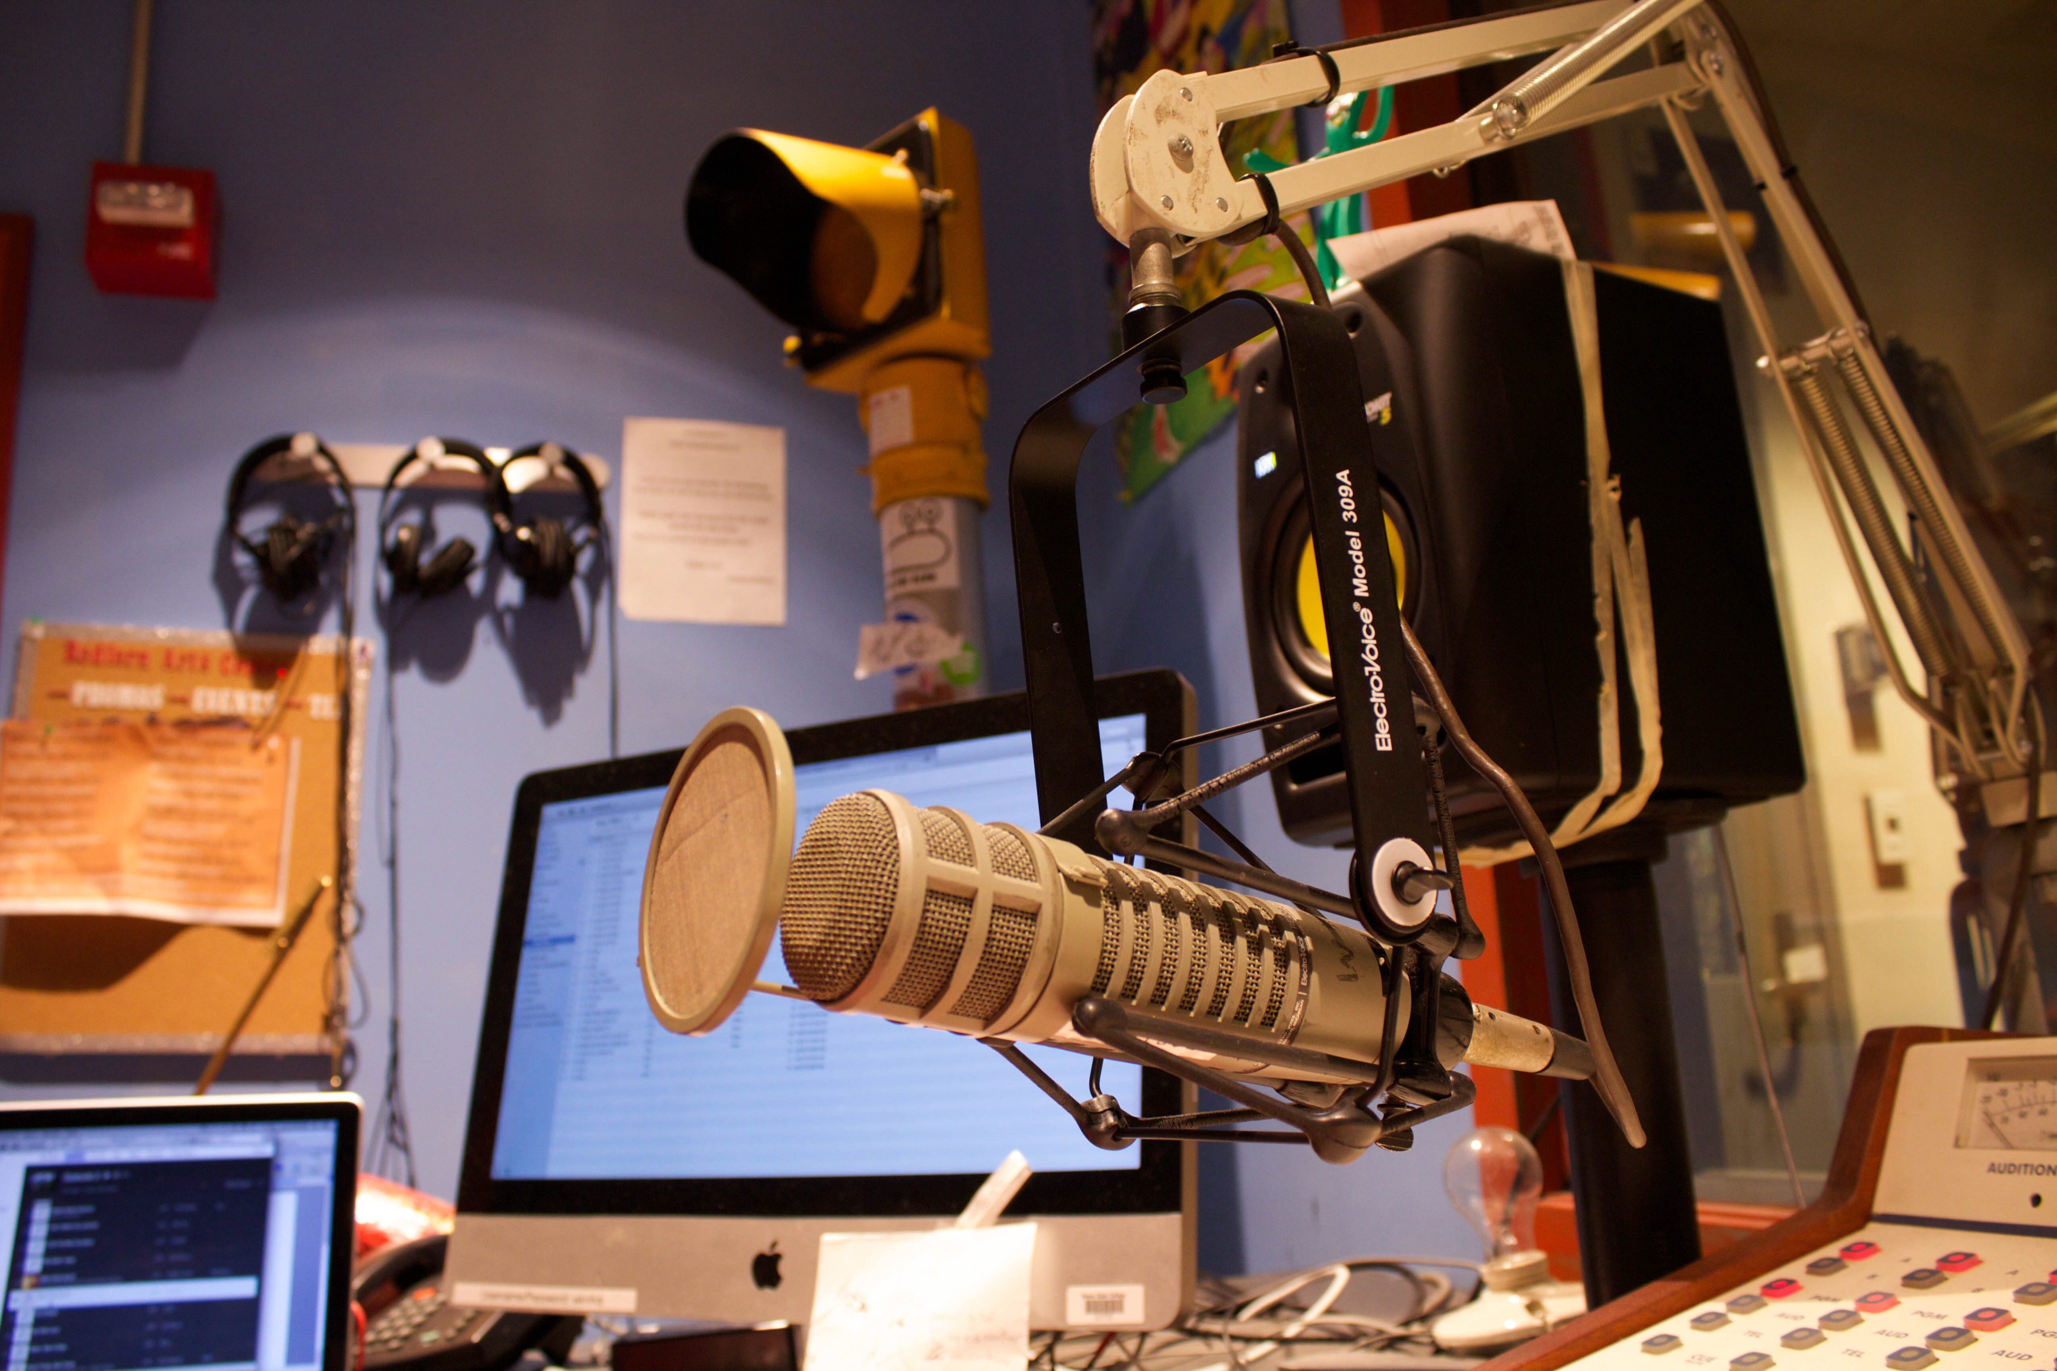The studio door also requires a secret code. As you enter, floods of posters distract your eyes from anything else. The beaming blue walls are hardly recognizable beneath the dozens of posters and drawings that students have hung up over the years. There are two single seat couches in the studio and two rolling chairs for hosts. There is a lot of counter space where the equipment sits. The soundboard is always glowing- the red buttons indicate that they are off and the yellow buttons mean that they are active. As you enter the empty studio, just the automation button glows yellow. The headphones should be hanging on the wall, but it is more likely that wires are tangled, and the headphones are scattered disarray about the studio. To the left of the speakers, microphones, and soundboard is a tall yellow pole with what looks like a standard single street light at the top. When it glows yellow, the microphones are engaged and the public can catch anything you utter. Be careful that this is not lit up when you are ranting about that frustrating professor or badmouthing your roommate. It wouldn’t be the first time.

“Hello and thank you for tuning in to WKNH 91.3 FM. This is your host Arline and you are listening to Arline Live in Keene,” the words float off my tongue into the mic and reverberate into my ears. No longer does the beaming yellow light in the corner of the station send nerves up my spine. Instead I find ease in knowing that for the next two hours, I get to speak and play music at my own discretion without the influence of anything but my own muse.

**Arline Live in Keene Fall 2014 Episode 1**

Playlist:

1. Keep On The Sunny Side- The Whites
2. Young Folks- Peter Bjorn & John
3. Chanda Mama- Playing For Change
4. I Will Follow You Into the Dark- Death Cab For Cutie
5. Is This Love?- Bob Marley
6. Ivory Road- King Charles
7. Brave Man’s Death- J Roddy Walston and the Business
8. If You Want to Sing Out, Sing Out- Cat Stevens
9. Grace Kelly- Mika
10. One Day- Matisyahu
11. I Got Stripes- Johnny Cash
12. That’s What’s Up- Edward Sharpe & the Magnetic Zeros

In preparation for my first live on air broadcast, I hand wrote a detailed list of songs and conversation pieces. I had a clipboard with all of the information attached that I brought into the studio with me.

I was surprised to arrive at an empty station. I thought experienced DJs would be around to guide me through my first show but I was alone. Shaken by nerves, I tuned out automation and said the legal ID for the first time on air, “You are listening to WKNH, Keene 91.3 FM.”

About halfway into the show one of the more experienced DJs stuck his head in to say hello. I will never forget how he barged in and picked up the clipboard, glanced back and forth from the notes I had written to my innocent face.

“Seriously? You wrote all this? What a nerd!”

He wasn’t trying to belittle me; I soon learned that his humor tended to hold this kind of condescending tone. Although I never sincerely found him funny, I never came to a show with notes again. From that point on, I stuck to the age-old method of “winging it.”

By the second half of my show, I began to sit a little taller. My quivering legs finally sat still. The number of times I said “uhm” per minute had reduced drastically. I was finding my footing. At the end of the show I thanked the audience for tuning in and announced that I would be there again next week.

Prospective DJs

WKNH has a handbook that any wannabe DJ must read before taking a test to qualify as a DJ. The test is not too dense and following the test a member of the e-board will review it with you and explain any answers you got wrong. Following this easy-going testing process, an experienced e-board member will show you the equipment and how to operate during your show.

Introduction of WKNH Handbook

Welcome and thanks for showing interest in becoming a DJ at WKNH, Keene! Since 1971, WKNH has been a student-run radio station and is the official radio station of Keene State College. WKNH exists, first and foremost, to train students in radio broadcasting and communications. Further involvement in the station can also lead to hands on experience in the fields of technology, finance, and journalism amongst other real world skills. WKNH also serves as a voice to the Keene community, working together with local citizens and businesses to ensure the preservation and constant growth of the arts in Keene. Our part in the process is done by booking radio-related events, concerts, featuring local artists live on air, and playing songs alternative to Top 40 radio among other opportunities. We hope you take part in our certification process, which involves reading through this handbook and taking certification/on- air tests, and join our DJ family here at WKNH!

**Words you CAN’T say on air:**

Shit Tits Motherfucker Cunt

Piss Goddamn Cocksucker Fuck

If you play a song with one of these words or if you accidentally say one you must fill out a form recording the time and offense. Although on occasion I have overlooked a lyric in a song and played one of the words above on air, I have never actually filled out the proper paperwork.

**Radio Jargon**

**Legal ID**: WKNH, Keene 91.3 FM (the proper way to announce the station)

**Automation**: the ongoing playlist of music running live on air during all times that no DJ is hosting a show, the music featured on automation has been downloaded by past and present WKNH DJs

**Stream Live:** Online at www.WKNH.org you can click and listen to the station live through the online server

**Program Log:** A document to be completed by DJs during each show, which records in writing the songs played, time of PSAs and promos, news/weather updates, and legal ID

**Obscenity Log:** An actual log, painted with the words that DJs are forbidden to say on air, it has a clip that holds the proper form to fill out if you are to violate this rule by playing an obscenity on air

**Dead air:** a span of silence on air, to be avoided, nobody likes to listen to silence on the radio

**PSA:** Public Service Announcement, there is a playlist of PSA’s in the iTunes library of the Mac in the station with hundreds of PSA’s to choose from, as a host it is required that you play PSA’s on your show, I can’t say that I follow this rule

**Feedback:** Responses to a radio show from listeners in the form of comments, online messages, phone calls or text messages

www.WKNH.org Home Page

WKNH is a non-profit, student-run radio station run by both college students and volunteer community members at Keene State in Keene, NH. Founded in 1971, we provide the surrounding area with diverse, non-commercial broadcasts both on the airwaves and with online streaming. WKNH features some of today’s (and yesterday’s) best alternative, jazz, world, hip-hop, metal, folk, & god-knows-what-else. Look around our website to find the [weekly show schedule](http://www.wknh.org/show-schedule/), [forms to become a new DJ](http://www.wknh.org/dj-forms/), and our different social media websites.

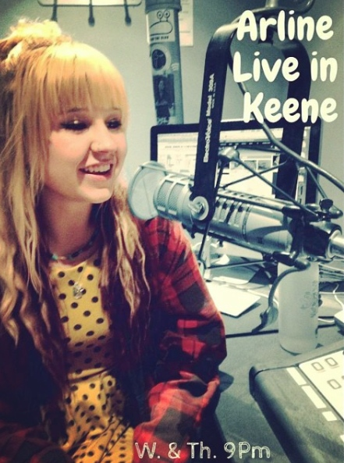

About the show:

Arline Live in Keene is a lively variety show based on the host’s favorite tunes. Featured genres include (but most certainly are not limited to) reggae, folk, rock, soul, indie and jazz. The show also features Arline’s insight regarding her experience as a Keene State College Owl. Often the music is infused with commentary on the college experience and being 20-something.

*I changed the Saturday night show time after one week when I realized it was not a good time to do my show. Everyone else was out and about enjoying the weekend night. I had no listeners and I was missing out on socialization prime time.

|  |  |  |  |
| --- | --- | --- | --- |
| WKNH SCHEDULE | Fall 2014 | Spring 2015 | Fall 2015 |
| Tuesday |  |  | 5-7 PM |
| Wednesday | 9-10 PM | 9-10 PM |  |
| Thursday |  | 9-10 PM |  |
| Saturday | 7-8 PM* |  |  |
| Common topics of discussion | * Transferring to a new school * Reasons to love Keene | * Heartache, breakups and moving on * How to remain positive | * Senior year, ways to survive college * How to remain positive |

“Cause they know, and so do I/The high road is hard to find/A detour in your new life/tell all of your friends goodbye/It’s too late to change your mind/You let laws be your guide”

–The High Road by Broken Bells

“Wow, you’re a radio DJ?”

The question comes up often. While it is exciting to discuss my experience, there is a lot about college radio that doesn’t measure up to the modern era of Sirius XM- primarily being the wave range. As I drive out of town I am always conscious to turn my dial to WKNH 91.3 FM to see how far out I can listen. Usually I barely make it past Keene’s town limits when the tunage turns to fuzzy noise- a disappointment to an aspiring radio personality. Only about ten minutes of driving away from the actual station the sounds of WKNH cut out. Of course, listeners are able to tune in online at WKNH.org, but even so there have been nights where I check my phone and find a handful of texts waiting to inform me that the listeners were unable to connect to the music server. I always explain that while I love to host my show, the title of WKNH DJ is a bit less glamorous than I had initially thought.

**Why I love hosting Arline Live in Keene:**

Hosting radio allows me two hours a week to speak my mind and choose the tunes without a single person interrupting. Unless I have a caller, which only happens occasionally, the two hours I spend in the studio each week is my time. I am allowed to discuss whatever has been boiling up in my body and I can choose songs that will help me release any tensions that have been building. There is nothing quite like speaking out without fear of another person cutting you off midsentence. I value my airtime the same way that yogis value being on their mat or sportsmen value being on the field. It offers me a place to create as well as decompress.

“Keep on the sunny side, always on the sunny side/Keep on the sunny side of life/It will help us every day, it will brighten all the way/If we’ll keep on the sunny side of life”

-Keep on the Sunny Side by The Whites

Missing Voice

Lost this past weekend while attending a late night musical performance in a local basement. If found please return promptly to Arline Votruba. Her voice is a valued tool that is highly necessary in hosting her radio show each week. It is a calming and sensitive female vocal with frequent giggles. Keep your ears open and please return her sound as soon as found.

“Hello listeners, thank you for tuning in! If you have any questions, comments or concerns do not hesitate to call in at (603)-358-TUNE, that’s (603)-358-8863!”

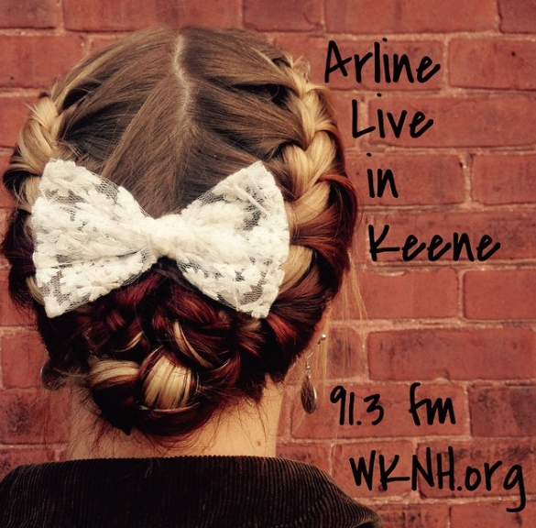Soundboard dim,

automation running

plug my laptop in

and start my playlist humming-

Slide the automation track down,

turn up the microphone,

welcome the town,

“On deck for tonight’s show-”

Pay attention, no dead air

when I make mistakes

deep breathes of despair

live radio has no retakes.

“Up next on the bill,”

or “that one is a favorite”

then “thanks for tuning in-

next week I’ll be in again.”

The following is based on a real experience while hosting Arline Live:

*RING*

“Hello caller, WKNH, this is your host Arline,” I answered the studio’s phone.

“Hi there, I just wanted to call to tell you that I am really enjoying your show. I listen to the college station a lot and you are doing well, some of the other hosts don’t play any music and goof around the whole time.”

“Well thank you, I appreciate the feedback.”

“Have a good night.” Click.

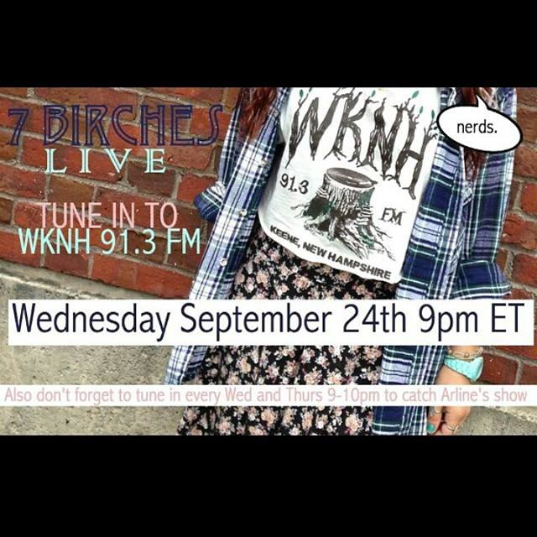My first boyfriend from middle school is in a band called 7 Birches. When they released an album I saw an opportunity to promote both of our artistic endeavors. I contacted Zakk and asked what he thought about me playing a song on the show. He was excited and all week we both flooded our Facebook pages with posts promoting the release of the new album. His page had links to WKNH saying that if fans wanted to tune in they would get to catch one of the new 7 Birches songs live on my show.

The night of that show I remember watching the number of online listeners rise- 1, 4, 7, 10- it was thrilling! Then, my phone began to buzz. Text after text showed up, all complaining about the same thing. The people trying to tune in online were unable to connect to the server, just as I started to earn a following the WKNH website failed me.

|  |  |
| --- | --- |
| Minutes ’til show time | Activity |
| 5 | enter station using key code, set mood lighting, plug in laptop |
| 4 | check sound, drink water, put on headphones |
| 3 | contemplate initial conversation for tonight’s show |
| 2 | drink more water |
| 1 | deep breath, fade out automation, fade in microphone |

|  |  |
| --- | --- |
| Minutes on air | Activity |
| 1 | phone buzzes, Text from Mom- “I’m listening” |
| 5 | realize a bathroom break is necessary, set up two songs to play |
| 25 | in the groove and rolling through the playlist |
| 40 | pause to discuss how the week has been |
| 60 | repeat legal ID, “You are listening to WKNH, Keene 91.3” |
| 90 | mention the Facebook page where listeners can follow the show* |
| 105 | wrap up the show |

*www.facebook.com/arlinelive



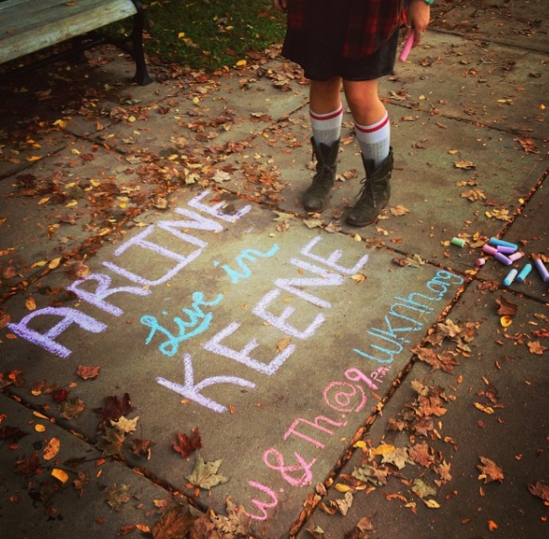

The following is based on a real experience while hosting Arline Live:

*RING*

“Hello caller, WKNH, this is your host Arline,” I say into the studio’s phone.

“Hi,” the man speaks slowly and pauses between phrases, “I wanted to call and tell you that if I had a woman in my life I would want her to be just like you.”

“Oh, wow, well I am flattered.”

“I just wanted to tell you,” he adds.

“Well do you care to share your name?”

“I would prefer remain anonymous.”

“Have a good night, thanks for calling.”

“Goodnight.”

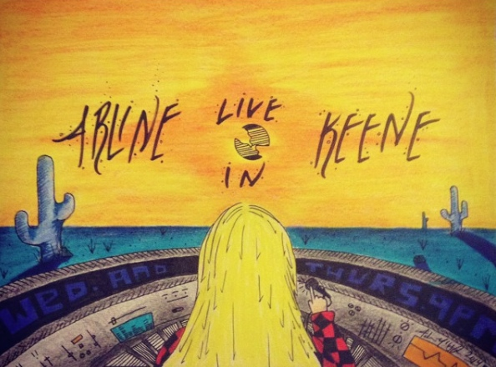Artwork by Adam McHugh

Mic on: “Thanks again for tuning in, it means the world to me to see that I have listeners during my show. You know, it is super important to feel as though you have supporters out there. Whether they are listeners of your radio show or friends who encourage you in your day-to-day struggle of classes and exams, it is crucial to surround yourself with people who will lift you up. Sometimes we find ourselves stuck in a rut, hanging out with people that we have for years but that no longer move us forward in a positive direction. It can be tough but I encourage you to evaluate your inner circle and decide whether they are pushing you to be your best self. If not, perhaps it is time to join a new club or group on campus where you can meet students with similar interests who are dedicated to being active. It is never too late, or too soon to make a change. That being said the next track I will play is by Bob Dylan, you guessed it, The Times They Are A Changin’.”

Fades to harmonica intro.

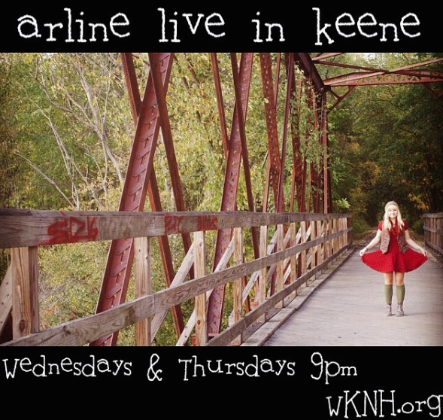

The following is based on a real experience while hosting Arline Live:

*RING*

“Hello, WKNH, Arline speaking.”

“Hi, I am calling to let you know that your levels are really low, I can hardly hear any of the music.”

“Yikes! Thanks so much for letting me know.”

“Have a good show.”

CLICK.

I immediately turn up the volume on my laptop and realize that was the problem.

“Coming up on tonight’s show I have a few tunes from my middle school days. Yes, we all remember the many awkward phases of the early teenage years. I could never forget that first day of 8th grade when I wore a hot pink fanny pack and black and pink striped sweatbands with my hot pink high tops. That day I sported a Paramore t-shirt, so here is an emo-phase-favorite Misery Business by Paramore. Hopefully you are able to unleash your inner most teenage angst.”

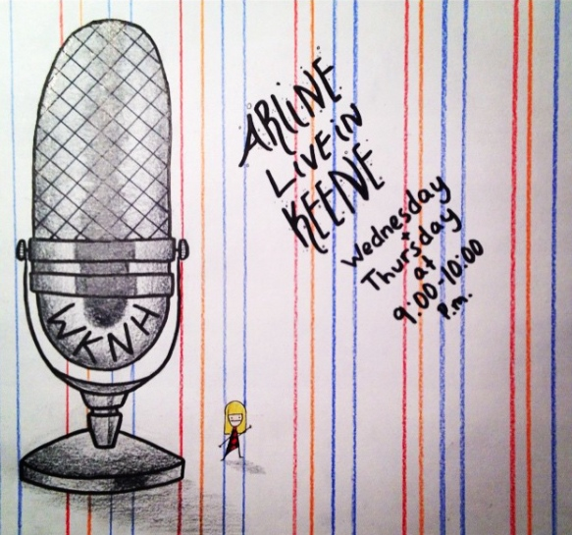

Artwork by Adam McHugh

WKNH has helped me to hear myself. It has allowed me to truly establish my voice and it has offered me an opportunity to fine-tune my communication skills. Many students who join WKNH are shy and feel like they are not capable of speaking out to a public audience. I always encourage people with fear of public speaking to consider the possibility because in the station you feel as though you are by yourself, a helpful environment to hone some of those skills. After several semesters of doing the show I find it easier to strike up conversation with strangers. I am capable of carrying on a discussion with the least talkative of people and sometimes people even tell me how they think I would be good at radio, to which I laugh and say that maybe I should look into it.

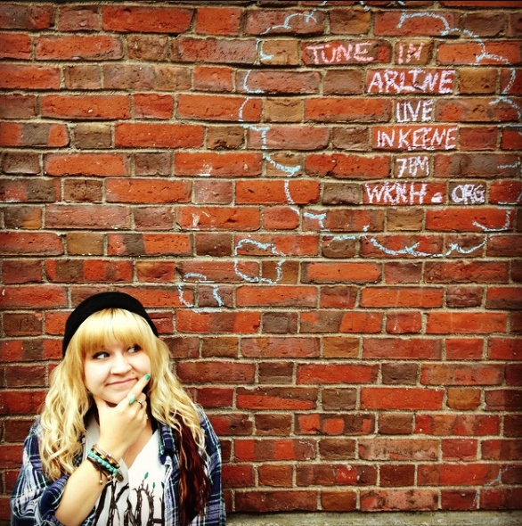

**Arline Live in Keene Spring 2015 Episode 4**

Playlist:

1. Where is My Mind?- The Pixies
2. Life’s For The Living- Passenger
3. In the Graveyard Now- Pokey Lafarge and the South City Three
4. If Not For You- George Harrison*
5. Booty Swing- Parov Stelar
6. War Pigs- Ozzy Osbourne
7. Let It Be, No Cry Mashup- Bob Marley vs. The Beatles
8. Roll Me Under- Joeannan
9. Ocean- Led Zeppelin
10. Folding Chair- Regina Spektor
11. Please Mister Postman- The Beatles
12. Live and Die- The Avett Brothers
13. Solsbury Hill- Peter Gabriel
14. Last Kiss- Pearl Jam
15. The Tide Is High- Atomic Kitten

*fan request

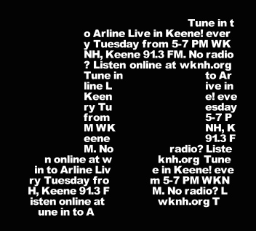

Over the semesters that I have hosted Arline Live in Keene, I have had many wonderful supporters tune in. Friends from high school, friends from previous colleges, regulars from the diner I work at, classmates from campus, coworkers, professors, Aunts, siblings, cousins and ex-boyfriends have all admitted to tuning in. Knowing that there are ears out there listening has been a huge influence to continue my live broadcasts. Some days I can see that nobody is tuned in online and it feels kind of lame to continue on. Luckily, over the course of my two hours in the studio the number of listeners usually fluctuates. This indicates that there are likely to be many people listening for brief periods of my show rather than just one person (namely my mother) listening through the whole time. It is the listeners who make radio a medium through which I feel compelled to express myself and it means so much to know that I have had the support of so many people.

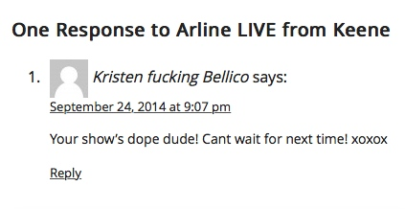

Some more feedback:

“Another awesome show- Ella Fitzgerald and Frank Black in the same show- That Eddie Brickell song brought me back too- rock on!”- Nathan, co-worker at Luca’s, text message

“Very enjoyable show tonight! Thank you.”- Mom, text message

“I hate that I have class when you’re on. Miss listening to Arline Live in Keene.”- Lucia Fox, friend from Endicott, Facebook comment

“Nice song choices.”- Mom, text message

I was initially introduced to the idea of hosting a show at WKNH by word of mouth. A friend of my brothers asked if I was planning to have a show, to which I responded that I had no idea the college had a station. She went on to tell me that I could attend a meeting Sunday at 8 pm in the atrium room of the student center. I followed her suggestion and three semesters later I am still hosting a radio show.

I find that people are often curious about what connections I have made through hosting WKNH. To be honest, the station is a popular hang out for many students, but while the lobby is often filled with other hosts and their friends my experience at WKNH has been mostly solitary. For me, hosting a radio show gives me a certain block of alone time per week embedded in my schedule. At times I have invited guests to hang out while I host my show so they can keep me company or get more acquainted with the station, but generally I do it alone.

“Thanks again for tuning in to Arline Live in Keene, I will be here next Tuesday from 5-7pm. Have a beautiful week, signing off this is your host Arline.”

**The Saga of Olive**

By Arline Votruba

I hate bipolar. I hate alcoholism. I hate depression. It is some combination of these awful personality disorders that have enraptured, captured and trapped the soul of my very best friend.

*My roommate hates me because my father has never molested me. My roommate hates me because I have never blacked out. My roommate insists that I do not understand life, that I can’t understand such concepts, because I have never been in the positions she has. My roommate was once my best friend.*

Olive exploded tonight. A tiny black stone in her chest erupted wild tendrils of hurtful words across the kitchen floor. They slithered around my legs and up around my spine until I couldn’t breath.

I walked toward the doorway, turned and said something like “I am going to my room because I haven’t had a chance to speak.” I realized I must remove myself from the scenario. I am only disturbed that I got wrapped up in it for so long. “I hate you,” she’d yell, “You live on a fairy cloud and don’t believe that bad things can happen.” She was a broken record on a hateful track. Black out drunkenness will do that to a person, especially a person prone to blackout drunkenness. While Olive is mad at me for taking control of my life she is fighting a battle with alcoholism that she refuses to recognize.

“You don’t understand.”

“Olive, I am not--”

“You have never blacked out and you think you are all high and mighty.”

She never gave me a chance to speak.

One August day…

I unfold my beach blanket and let it blow out in the breeze before setting it down on the tiny patch of grass we call our front lawn. Olive lights up her cigarette, we clink our bottles together and toss back another sip of Redd’s Apple Ale. I can feel a bead of sweat run from my hairline down to my chin before it drops off onto the blanket. I sit down and start the Summer 2015 playlist that I created weeks earlier through my phone. We are both wearing sunglasses that cover half of our face.

“Too bad we didn’t wake up early enough to go to Hampton,” Olive says. “What? This great view of The Savings Bank of Walpole doesn’t relax you?”

She giggles at my snarky commentary- her smile so genuine and pretty. I will always remember Olive’s smile, since the day I met her I never saw another human smile quite as bright.

Dear Black-Out-Drunk-Olive,

Please drink a glass of water and eat a piece of bread then proceed to read the following.

If you had given me a chance to speak I would have told you that I understand that rape exists. It is a disgusting and foul crime that is committed against defenseless men and women. It could happen to anybody, I am certain that such atrocities play out in unexpected circumstances. Often times these circumstances are out of the control of the victims. Other times the victims could have been more cautious about what situation they got themselves in. That is all I am saying. Despite the words you have been trying to write off as my own, I never believed that a person deserved to be raped. I can’t believe you even suggested such an awful idea.

It pains me to imagine a day in your life when a grimy soulless hound mounted you and stole away a certain innocence that cannot be regained. I hate that you can draw to mind the memory of a body unresponsive, or can’t you, I am still a bit fuzzy about what happened to you exactly or what you can remember. I wonder if tomorrow you will remember this.

I am sorry for your awful experience but there is no reason for you to be mad at me for not sharing your awful experience. A friend would be glad to know that I was never abused in such a way. Instead you choose to mentally abuse me over my life free of sexual abuse.

Olive, if your father molested you, that is something that I can’t understand. My father respects me and loves me deeply and tenderly in the utmost fatherly manner. He could never diminish my trust by taking advantage of me, and the fact Joe ever laid a hand on you makes me despise him gravely.

I am sorry I can’t change your past and I am sorry that you do not understand that I wish for you only the best in your future.

Sincerely,

Your Ex Best friend

Two weeks in this new school

Snowflakes coat the town’s floor

Starving for new friends

I leave my dorm to explore

Returning to the house from last week

Where pong battles fueled the fun

Welcomed in, “She’s the transfer, don’t freak”

But really I knew no one

Gazing into the blur of bodies

Sipping from my flask

My eyes locked with a friendly face

She greeted me with a gasp

“Hello! Name’s Olive, how are you?”

Later people thought we were old friends

An immediate bond like Shaggy and Doo

Laughing hard until night’s end

In the following weeks she’d call me up

Party on Wilcox, Marb, or Davis tonight-

We’d meet at her dorm and swallow some shots

Everything seemed all right

Semesters rolled by and she asked me to move in

With her and the other roommates

At first it was swell, the summer smooth and

then a sudden twist of fate

She screamed in my face, words full of hate

She told me to go away,

Weeks later she snapped,

Elsa was attacked,

So it’s time I go on my way

Fight # 1 (Demonstration: substance control issues):

Olive was sitting by the end of the coffee table. I was on the couch. I had just cracked a Redd’s Apple Ale. I look at the table. It is covered with random piles of ash, empty beer cans, a cat toy, a remote controller, a pipe filled with black ashy residue and a few scraps of old mail. Olive declares that she wants to trip. She turns to me and asks me to go pick up our roommate who will bring along the drugs. I refuse. I explain to her that my rules are set in stone- I have began to sip my drink and so I will not drive. She calls me a pussy. She tells me I am a fool and that I have in fact driven after drinking before. I can’t believe that she is yelling. She calls me a bitch. She mocks me, and suggests that I do not need to cry about it. I didn’t cry, but I left.

Fight # 2 (Irrationality in the form of champagne):

I arrived home after work in good spirits. Olivia approached me and gave me a big hug, feeling good off spirits. She says that she is drunk and follows by telling me how much she loves me. Not two hours later we are in the kitchen. She is screaming at me about how I do not understand. She says it is not possible that I could know. She yells at me about how my life is not reality and that in the real world people get taken advantage of. I never disagreed with such a concept but she continues to put words in my mouth, yelling louder than I can.

Fight # 3 (Last round):

Things got physical. 58 Willow is no longer home.

Her eyes were replaced with daggers and the tone of her voice had changed. She spoke in a shrill and sassy way that exuded the obnoxious sound of a young girl whining. Her fists became clubs are she wailed them against the door. Her head had grown to five times its natural size. She shook the house with every step.

If a kitchen refrigerator could play jeopardy mine would win the following categories:

* Who has not been doing the dishes
* Who has not taken out the trash
* Phrases Olive screams at friends when drunk
* Number of beers Olive has drank (per night and per week)
* Food items Olive threw away that belonged to others
* Drugs in freezer
* Food gone bad

Inventory of things I gave to Olive:

* Spring Breakdown, House Bunny and Joe Dirt on DVD
* Limited edition American Spirits cigarette tin
* Rides to therapy
* Poster I hand-painted for her room
* Incents
* 3D star decoration- meant to hang from ceiling
* Blue and green flannel
* Trust

Things Olivia and I talked about this summer:

1. where we were going to lay in the sun for the day
2. whether or not to buy a pack of cigarettes
3. pros and cons of working out
4. how it feels to be a senior
5. work and summer courses

“My Dad would love this kitchen!” Olive beamed.

She wandered from the sink to the fridge, then to the back hall. Back and forth she would go, opening and closing every cabinet and drawer.

“You know he designed our house, but he would love this.”

Thinking about it now, even then after a few beers her tone wasn’t so much complimentary as it was argumentative. Of course she was offering nice comments, but in her words was an underlying hint to the rage bottled inside.

“Want to do some shots?” Unknowingly I grabbed the bottle, pouring and enabling her without concern.

58 WILLOW ST APARTMENT 2- LATE NIGHT/EARLY MORNING

*OLIVE enters upstage left. She tosses her arm around ARLINE’s neck, pushes her face while tugging her hair. OLIVE rips at ARLINE’s braid.*

*Lights go down.*

*Spotlight shines on ARLINE sitting on bed downstage right.*

ARLINE

It wasn’t until later that I realized she had taken the elastic with her. When I had eventually wriggled free from Olive, Elsa locked us safely in her room. Olive persisted, beating her fists on Elsa’s door while screaming threats. I can’t believe she broke my glass mug. A friend had purchased it for me at a thrift store. It was glass, painted with a smiley face above the words Class of ‘77. She smashed it against the hardwood in the hallway sending tiny shards under the door into our safe zone. She didn’t let up. We had to call the cops. We had to didn’t we? Do you suppose that this was my fault?

Thursday night- 1 week ago- October 8, 2015

2:45 AM my phone buzzes:

Hey can you please wake up… There is this random kid that wants to walk me home from your house and I’m nervous you are the only sober one

I peel myself out of bed, Goosebumps rise like soldiers of my chilling devise. I slide on a sweater, tug on my Uggs and step into the light, it is hard to adjust but I notice a couple of hazy blobs in Elsa’s room.

“Hey,”

“Oh my god, I am so sorry to make you wake up,” Becca says.

“Stop, no worries. Seriously, I am happy you asked me. I don’t want you walking home with him, or for anybody to drunk drive.”

“She told me to ‘Get the fuck out of my house.’ She screamed at me. Should we just go?”

“Yeah, let’s go.”

I park my jeep wrangler outside Becca’s apartment. She is wearing a mesh pink tank top that buttons down the front. It has a collar that looks great against her red hair. She is older than I am but she is still just a puppy to the world, sweet and loving but very naïve.

“Becca, something you need to think about when you go out with her is that she can snap like this- she changes and you should be careful whether you rely on her when you are drunk at the bar.”

Who knows how many times they have been to the bar since.

If there is one thing that my degree in Creative Writing has taught me, it is that there are uncountable ways to tell a story. The same story could be reworked into so many combinations of words that it transforms from horror to romance without the events themselves ever changing. There is no limit to the ways a scene can be conveyed on paper, or through an oral account like the one Olive gave tonight. She said her side of the story. Loudly. At my face. Again. Then again. Blacked out and yelling at me about how I am stupid because I don’t believe that people black out.

You try to hear your thoughts but they are drowned out by the crash of broken glass sliding across the back hall. You look around, knees whimpering in horror. A chill runs across your skin, leaving every hair stiff, alert. You remember movie nights and dinner dates and road trips and porch chilling and campfires and visits home and nights spent drinking together and nights spent drinking together and nights spent drinking together vanish into a time you now refer to as before the incident. Thumbing the numbers on your phone you dial 9- can I do this? 1- almost there. 1- goodbye to our friendship. The police arrive shortly thereafter. She plays dumb having cleaned up the broken glass before their arrival. When the cops leave you wonder how it ever came to this.

An Open Letter to Alcoholism:

Hello my name is Arline and I am an addict’s best friend,

Not just once in my life have I found myself in the position of pulling a loved one from the deep well of misery your empty bottles, cans and flasks provide.

Let go of her. You serve no purpose and contribute nothing but nightmares to the lives of your victims. So what they invited you? You are not welcome anymore. Go back to where you came from- the vine, the barrel or the cabinet. Your fermentation of fun nights and falsified confidence deserves extermination for the pain you’ve caused.

You leave a bad taste in my mouth.

You have taken things too far this time.

Sincerely,

Arline

I entered the Davis Street house and kicked off my boots.

“Hello! Anybody home?” Turning the corner into the living room I found Olive in her usual position- legs up in the pink recliner with her orange laptop open.

“Whatcha lookin’ at?” I asked as I made myself comfortable on the futon.

“Trying to decide what to drink this weekend. I am thinking peach vodka.”

“You shop for alcohol online?”

“Every week, I like to check out the sales.”

I giggled at the idea of her weekly ritual.

We hung out in the living room for the rest of the afternoon. The huge TV with its bubbled glass screen buzzed as it blared episode after episode of Modern Family. Eventually Olive’s phone buzzed.

“Oh, Dan is out of class, he is going to buy us alcohol now!” She nearly sprung off of the couch, the first movement I had seen all afternoon.

When Dan brought us our bottles Olive instantly cracked hers open.

“It’s going to be a good night,” she beamed, “I am going to take a shot before I hop in the shower.”

I waited on the couch flipping through a copy of Cosmopolitan I had snagged from the gym. Eventually uncorking my bottle of wine.

Sunday morning hangovers are best served at Lindy’s Diner. Smooth milkshakes and hot pancakes wash away the rumbling aches of too much liquor. Olive and I would roll out of bed around 10 am and hop into my jeep. The ride across town always seemed longest on those mornings.

My favorite part of breakfast was taking turns feeding dimes to the mini juke box at our booth.

“Your turn to pick!”

She chose Brown Eyed Girl but the juke box played another Elvis tune anyways. Sometimes we would select a song and nothing would happen. After a long span of silence passed and we had forgotten about the whole thing all of a sudden the box would start producing music.

When the check came I would pay, Olive would thank me, and we’d head back to the apartment for a late morning nap.

**Detailed Description of photo piece based on Ellen Birkett Morris’ “John Birkett”(Creative Response):**

There are dark circles permanently embedded like upside down umbrellas below his chestnut brown eyes. His hair is always either short or very short but it doesn’t matter because it is hidden beneath a bandana when he cooks. He is 6 foot 5 with a small beer belly. His olive skin is tan. Most days when I see him his face is already shiny with grease from the grill. He always gives me a smile. In the photo he is with his best friend Byron. I remember him telling me stories about his neighbor and long time buddy Byron years before we ever actually met.

This writing helped me to think of the possibility of incorporating photos into experimental works. It challenged me to consider how one should write about a photo. This piece is also challenging me to consider how one can intertwine two stories (in this case my relationship with Rayray and my relationship with Byron) and clearly demonstrate where the tales intersect and where they are separate from one another.

**Multi Genre Handbook Chapter**

Greeting cards are generally sentimental notes we send along for a particular event or celebration. Some of the most popular occasions one sends a greeting card includes anniversary, baby & expecting, back to school, birthday, congratulations, graduation, thank you, religious events, wedding & engagement, sympathy, get well, good luck, moving, love, sorry and thinking of you. A greeting card is brief, it may or may not rhyme, you can be general or specific, serious or sarcastic, but it is important to be creative!

In an experimental writing piece we might use the traditional concept of a greeting card and turn it around to emphasize a point ironically. We can reassign the traditional use of a greeting card, generally a kind gesture, with an alternative approach to the genre.

For example, greetings could include statements such as, “Congrats! You’re fired!” or “Happy Bad Hair Day!”

Incorporating a greeting card into an experimental piece can take may forms. You can feature the image of the cover, share the interior message, or include an image of the entire card in your piece.

Some examples of ways to incorporate a greeting card into an experimental essay include:

“Congratulations!” card to somebody who rear ended your car

“Thank you for your thoughts…” card to a landlord who has sent you an eviction notice

“Good luck on your move!” to a character attempting to move on from a relationship

In the age of technology, eCards have in many ways replaced standard greeting cards. Electronic greeting cards can be sent via e-mail, Facebook or text message. Incorporating one of these into an experimental piece can help to incorporate technology into a piece based in recent years. A found e-card could be incorporated into a piece, or you could create your own.

While writing a greeting card for an experimental essay, remember to be brief, specific, and pay close attention to the visual appeal of the piece.

Writing Prompts:

* Reimagine a conversation between two of your characters as a greeting card (fortune, e-card or postcard) from one character to the other.
* Explore free online greeting card generators to make a visual piece to incorporate into one of your experimental pieces.
* Write a greeting card that a character wishes they could actually send to another character in your story.
* Find an eCard online that might be useful as the heading or introduction to a section in an experimental piece you are working on.
* Reimagine your piece as a greeting card- how would you shorten it to a cover and inside message?

Where to go from here:

Taking an experimental writing course has taught me a lot about the limitless genres that can be incorporated into a written work to add dimension to the piece. It has expanded what I imagined as publishable material. The various writing prompts and exercises really gave me a better grasp on how much presentation and format can affect the readers’ experience. This is the first course where I have incorporated multiple genres in one piece and it was also the first course that inspired me to use photos in my writing. A long-time life goal of mine is to publish a book that is sold in the store Urban Outfitters and I think this course has helped me to generate ideas that move me closer to this goal. Following this course I intend to continue working on Live on Air, delving deeper into my WKNH experience and incorporating more scenes into the piece. In combination with this class I have been taking Photography 1 with Professor Gitelson. The combination of creative courses has provoked many ideas for me and one project that I have just started and intend to continue working on is Free Couches. I am gathering a collection of photos of free couches out on the side of the road, then I will caption each photo, perhaps including the date and location of the couch photographed. I think that this is just the kind of book that would be featured at Urban Outfitters, a quirky coffee table style picture book, and I will create it using strategies learned in this class.

Ultimately, my goal following this class is to keep on writing and to start sending my writing out for publication.

Permission Form: You, Kate Tirabassi, have my, Arline Votruba’s, permission to use any of my writing in future classes, conferences, or publications.