Pronunciation Tutoring Reflections
Assignment Description

In the pronunciation tutoring project, you will diagnose the pronunciation of an English learner, plan and prepare teaching materials, and teach four 50-60 minute sessions over four weeks. After each tutoring, prepare a report/reflection of the tutoring to turn in. It should include the following items.

- A description of how the tutoring proceeded.
  - What happened?
  - What order did you teach the items in and why?
  - What did you notice about the tutee’s performance in perception and production?

This session was a little bit different from all the others. In this final lesson, I attempted to integrate some CALL tools for pronunciation, some of which we were introduced in class, and some f which I was introduced by Monica Richards during her visit in my 511 class and finally, I integrated the ASR program, which is part of my Research Paper. The point of this integration was to provide the student with some existing tools for her future autonomous practice.
I taught the items in the same order, but with a different approach. I demonstrated the articulation process that happens during pronunciation of the target sounds and pointed out the difference in the tongue position for each of the sound contrasts she had problems with. She seemed impressed by the demonstration and requested that I send her all of the links that I used and downloaded one of the ASR programs I recommended. Furthermore, we continued with YouGlish and the student stated that she loves the exposure to language, especially when she’s not sure of a pronunciation of a word and the fact that there is a tool that can help her hear a flood of input by native speakers used in different contexts. Her perception has improved significantly with both segmental sounds.
We continued with the ASR program to check her production. The program demonstrated some flaws of course, but in general it was an interesting and useful way for the student to notice that she pronounces /s/ instead of /θ/ in few positions, especially at the end of the words. As for vowels, it proved useful for her to notice the extensive use of the vowel /æ/. I also modeled my speech to check the program’s reliability. I sometimes give examples of my difficulties, as for the case of the vowel /æ/, I pointed out that this particular vowel is a problem for Macedonian speakers, and it is great that she is able to produce it, but also to be careful not to confuse it with the vowel /ɛ/. We also tried the North American highlighter but only shortly due to lack of time. The student was very excited for having the opportunity to know all these resources for future practice.
Then, we continued with a short Role Play. The task was interesting and included many words with the target sound. The student still has problems in free speech, but she is trying to use the sound correctly and more rarely confuses it with the /s/ sound, which I think is a great progress. I pointed out that fact to her, and she confirmed that she pays more attention now in pronunciation of the /th/ words but that it is still difficult for her when the sound appears in certain environments.
Finally, we got some revision about Stress. We read a short dialogue and changed roles. I took notes of the things I wanted to point out. For example, she never reduces the vowels of the unstressed words. I asked her which of the words are stressed for her, and she said that she doesn’t use stress at all because in her mind she’s thinking about the vocabulary, Then I made her read one sentence out loud and I pointed out the good uses of stress, and I encouraged her that, in fact, she does use stress, and it is not as bad as she thinks. This positive appraisal lifted her spirit up and she was more eager to continue and try out to stress the content words and shorten the unstressed words. After that we tried linking of some phrasal verbs, which was very difficult for her initially, but got better throughout the process. I stopped here due to lack of time and we didn’t finish the last exercise.

- A reflection and analysis of your own performance as a teacher.
  - What went well?
  - What did not go so well? Were they any exercises that didn’t work? Why?
  - What surprised you?
  - Were there things you did that you would change for next time? Explain what they were and why you would change them.

The student was pleased by the use of technology and the possibility for her to continue practice on her own. Maybe I should have saved more time for the revision of the Stress section, but we spent a lot of time with the ASR program, because she found it very interesting and kept trying until she got the word correctly. I was surprised by her enthusiasm and eagerness to continue working on her pronunciation; both on her own and together. She said that she’s satisfied with the tutoring and willing to continue next semester if I had time. We created a great relationship and promised to keep in touch. I believe having a good relationship with the student is one of the most important aspects for increasing the interest of the student and thus getting them more productive. I am generally very satisfied with the tutoring. I didn’t completely ‘fixed’ all the problems, but her perception definitely improved a lot. And as we discussed in class, once a person is able to perceive the sounds, s/he will more likely be able to produce them eventually. Just like me with the tense and lax /i/ sounds. Of course, it takes more time for one to improve their pronunciation but where there’s a will, there’s a way. Eagerness to learn, practice and improve is what I believe my student gained above all, and that will be very helpful for her in the future. I think this was the most valuable experience that I had and the best aspect of the course. What we learned is put into practice and we experience all the things we gain knowledge of and discuss about in class. Priceless.
Finally, as stated above, I would save a little bit more time for the last target. If we had time to finish the last exercises, it would’ve been just perfect. In general, things I would maybe change is the integration of CALL tools in small parts throughout the lessons and adding more communicative tasks. I included some communicative tasks throughout the lessons, but once it failed due to choosing not interesting topic for my student, and once it I did not have time to get to the task. My starting opinion was that the communicative tasks are the best option for practicing pronunciation, and during my experience I found out that the controlled exercises are needed more, at least at the beginning. However, it is still important to get the students to speak and use the sounds in context.

- Any questions that you would like us to address.

Would it be better if I integrated the tools from the beginning and use them as smaller integrated parts in each of the sessions or is it better to just be the model for your student and not relying on technology in each lesson? I’m just thinking what would the student benefit more from and would that maybe (as non-native speaker) indicate like my insecurity of the pronunciation of the sounds?

- Include your lesson plan for the week and the exercises you used. You may make comments on the exercises if it helps your analysis, or you may integrate your analysis, reflections, and exercises all together.

Remember, it is important to describe fully, but it is equally important to reflect and analyze your own performance as a teacher.

(/ɛ/- /ey/-/ɪ/-/ æ/)
Ear Training
- University of Iowa phonetics
http://soundsofspeech.uiowa.edu/index.html#english

- YouGlish
Listening to the words distinctions
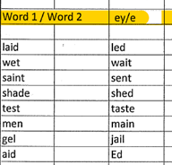
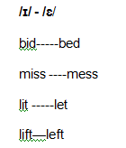
/ ɛ / /æ/
dead dad
head had
bed bad
said sad
end and
lend land
send sand
beg bag

Production
- Using the ASR program (Enhanced dictation) to write down the learners speech
- Trying out individual words
- Trying out sentences
- I told her a joke and she laughed. I told her a joke and she left.
- Can you please give me the pen? Can you please give me the pan?
- I saw the man with the yellow coat. I saw the men the yellow coat.
- He lift the stone. He left the stone.
- I saw the big jail. I saw the big gel.
- She had a great taste. She had a great test.

- North American Pronunciation Highlighter
http://www.relateworldwide.org/speaking/pronunciation/pronouncing-individual-sounds/pronunciation-highlighter/
TEXT: Sometimes people extend indefinite invitations and don’t really want them to become definite. They may say at the end of a conversation, ‘I’ve got to go now. Let’s get together soon.’ For some people, this simply means, ‘I’ve enjoyed the conversation with you. I hope we can talk again.’ If this is the case, the person is probably not interested in making the invitation definite. It isn’t always easy to know when it is worth trying to change an indefinite invitation to a definite one. To get an idea of how sincere the person is, you could ask ‘Do you want to set a date now or would tou rather wait to do that?’ If the person is too busy to be able to plan a time to get together, then it may be that he or she is really not interested in extending a definite invitation.

/θ/ - /s/
Ear Training
- University of Iowa phonetics
http://soundsofspeech.uiowa.edu/index.html#english

- YouGlish
Listening to the words distinctions
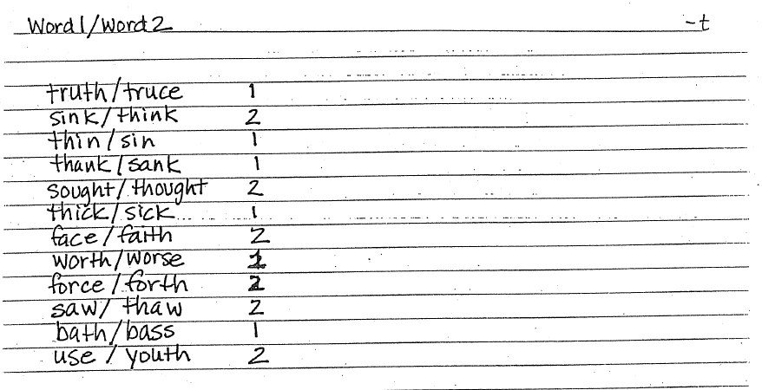
Production
- Using the ASR program (Enhanced dictation) to write down the learners speech
- Trying out individual words
- Trying out sentences
- The man is sinking. The man is thinking.
- Tom has a really big face. Tom has a really big faith.
- That is unthinkable. That is unsinkable.
- They have s a big mouth! They have a big mouse!

- Role Play
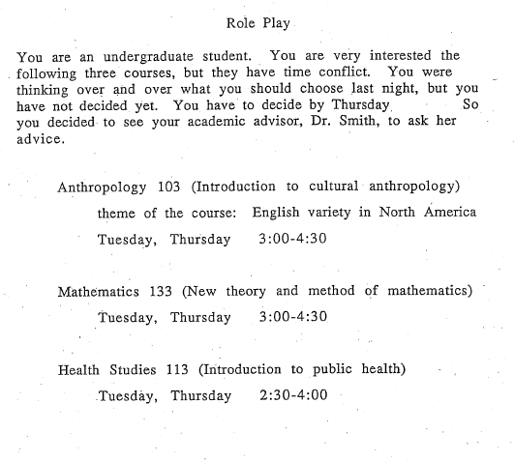
Stress
- Which word in the phrase is stressed?
- Which word is unstressed?

A: Excuse me, could you give me a hand?

B: I’m not sure. What did you need?

A: I’d like some help moving this table. It’s very heavy.

B: Where’d you want to move it?

A: I wanted to move it up to the next floor.

B: That’ll be too much for just two of us. We’ll need more people.

‘Resyllabification CC +V sequence
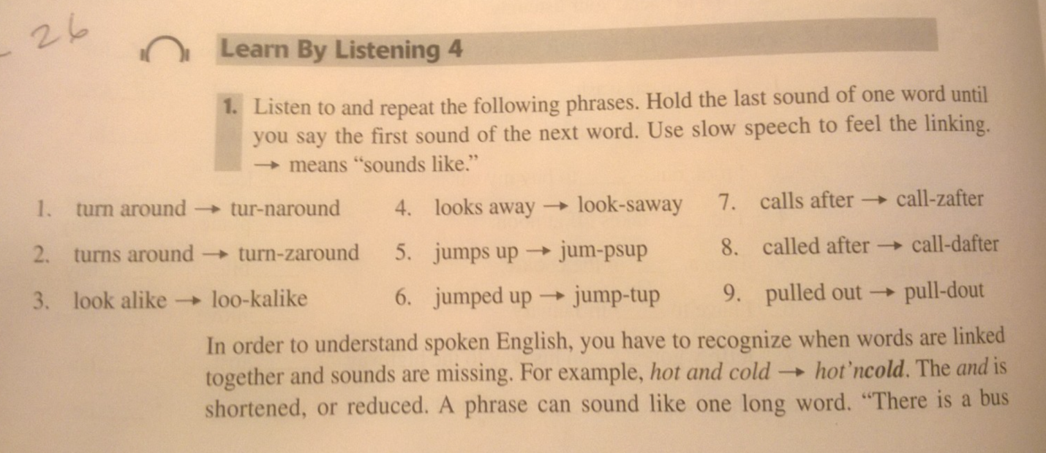
Role Play