Pronunciation Tutoring Reflections
Assignment Description

In the pronunciation tutoring project, you will diagnose the pronunciation of an English learner, plan and prepare teaching materials, and teach four 50-60 minute sessions over four weeks. After each tutoring, prepare a report/reflection of the tutoring to turn in. It should include the following items.

- A description of how the tutoring proceeded.
  - What happened?
  - What order did you teach the items in and why?
  - What did you notice about the tutee’s performance in perception and production?

The lesson went on nicely and as planned. As usual, we started talking about general things and I was paying attention to her speech in terms of how she is using our targets. I noticed that she still has certain problems when it comes to the /th/ sound but mostly her errors comprise substituting /th/ with /s/ when it appears at the end of the word. We had a long stretch between the previous session and this one and I believe she stopped paying attention to the correct pronunciation. Due to our schedules overlapping and the circumstances we couldn’t meet for two weeks. I would note that as negative and as for the future, it is good to know that when teaching pronunciation (at least the short term teaching like this one) should not include long breaks between the lessons because the students start to relax and lose track.
The items were taught in the same order as the previous classes to keep the continuum. I started with a revision of the following sounds (ɛ/- /ey/-/ɪ/). I used some pictures to elicit the words from her without reading and she produced the words correctly. Furthermore I took one exercises from the diagnostic where she mixed up these sounds with notes only for me (her copy did not have notes, but only the words) of the sounds she mixed up. I found out that she has overcome most of the difficulties she had before, and the only problems she has around these sounds is that she makes the /ɛ/ a little bit longer or she uses her ‘go-to’ vowel /æ/ so I explained the differences in production and corrected her production accordingly.
As for the / θ/ sound, I had an exercise with minimal pairs of all three mixed sounds / θ/, /t/ and /s/. What I noticed is that when she pays attention and tries to produce the sounds carefully she is successful. She only struggles when / θ/ is at the end of the word. I also included more interactive, communicative and guided exercises in this lesson plan for all three targets which she seemed to enjoyed.
Last but not least, we revised stress patterns and introduced the topic of reduced vowels. Her reaction was that this is a moment of enlightenment and she finally realizes why she doesn’t understand American people when they speak. The exercises were very interesting and delightful and I had the feeling that she really enjoyed that part of the lesson. I asked her if she has any questions on any matter and she replied that she understands the last target bus she would not be able to integrate it in her speech yet because she doesn’t feel that she is at that stage yet. I encouraged her and explained that once she becomes aware of the connected speech and reduced vowels, she will start paying more attention to native speakers’ speech and gradually it will become part of her speech as well.

- A reflection and analysis of your own performance as a teacher.
  - What went well?
  - What did not go so well? Were they any exercises that didn’t work? Why?
  - What surprised you?
  - Were there things you did that you would change for next time? Explain what they were and why you would change them.

Generally, I am very satisfied with this lesson. I can see that I getting better with time management and the usefulness of the exercises. My tutee feels comfortable and she is starting to speak more and more with me on general topics, which is great for our communication and great for her to practice her English fluency, first of all. I have the feeling that I should have added more controlled exercises to provide more exposure of the sounds. I had the feeling that this lesson was more focused on her production, rather than ear training. In fact, that is what she requested and I wanted to see how it will go. It wasn’t bad, I gave feedback, but still, maybe it’s better to give a little more exposure before I go on with production and feedback.

- Any questions that you would like us to address.

As mentioned above, I noticed that she inserts her ‘go to’ vowel instead of /ɛ/. Should I integrate exercises for the distinction between these vowels, or that would confuse her even more?

- Include your lesson plan for the week and the exercises you used. You may make comments on the exercises if it helps your analysis, or you may integrate your analysis, reflections, and exercises all together.

Remember, it is important to describe fully, but it is equally important to reflect and analyze your own performance as a teacher.

WEEK THREE (ɛ/- /ey/-/ɪ/)

Review
- Great exercise, she produced the words without reading which allowed me to see that can produce the (ɛ/- /ey/-/ɪ/) sounds generally in a good way.
- Find the /ey/ words in a picture
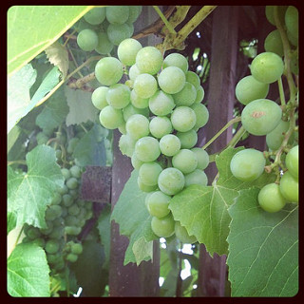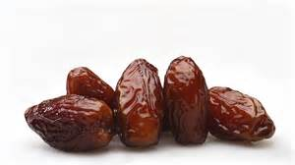

2. Circle the word you hear (I read first and then she reads) This is an exercise from the diagnostics and I took notes of the vowels she produced incorrectly then, and compared to her progress now. Great progress!

/ɪ/ - /ɛ/
bid-----bed
miss /ɛ/----mess /æ/
lit /ɛ/-----let
lift—left
/iy/ - /ɪ/
beat----bit /ɛ/
leap-/ɛ/ ---lip
/ey/ - /ɛ/
late----let
mate /ɛ/----met /ɪ/
laid /ɛ/----led

Production
1. Same/different My point with this exercise was too see if she can produce both sounds interchangeably and my answer is positive, even though she sometimes uses /æ/
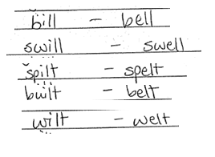
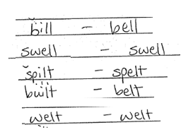
2. Word1/Word2 Interesting exercise, it was not difficult for her, she filled in the gaps and read the sentences, again, the same problem appears on some places when it comes to producing the vowel /ɛ/

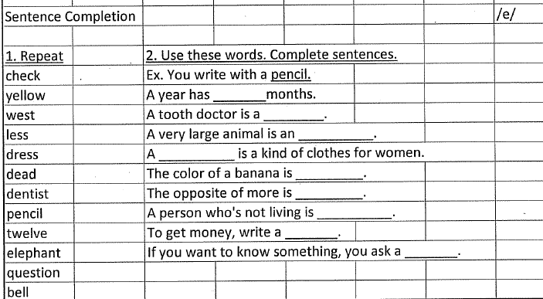

3. Reading We read the dialogue, so I could see if she can use the sounds in larger context, good exercise! I took notes of some of her flaws and gave her feedback
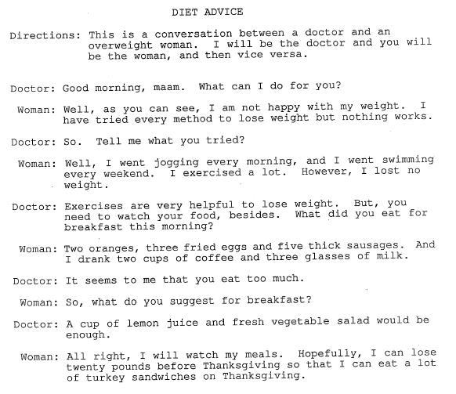
4. Appropriate response I planned this as a guided/communicative exercise, and she gave me good longer responses which allowed her to use the target sounds
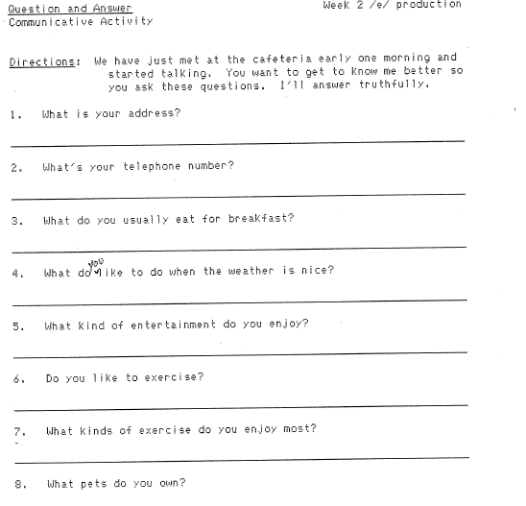

WEEK THREE /θ/ - /s/

Ear Training I was planning to read the words first to expose her to the sounds, but she preferred that she reads first and I give her feedback on her errors. That worked well, but I still think I should have read the words first
- Distinguishing /θ/ - /s/ - /t/

- thank tank
- theme team
- thin tin
- thinker tinker
- thought taught
- both boat
- thank sank
- thigh sigh
- thimble symbol
- thin sin
- think sink
- thinker sinker
- thought sought
- thumb sum
- thick sick
- unthinkable unsinkable
- faith face
- fourth force
- math mass
- moth moss
- mouth mouse
- north Norse

Production
1. Repeat words with /th/
2. Dialogue reading Fun and interesting exercise for using the sounds in larger context.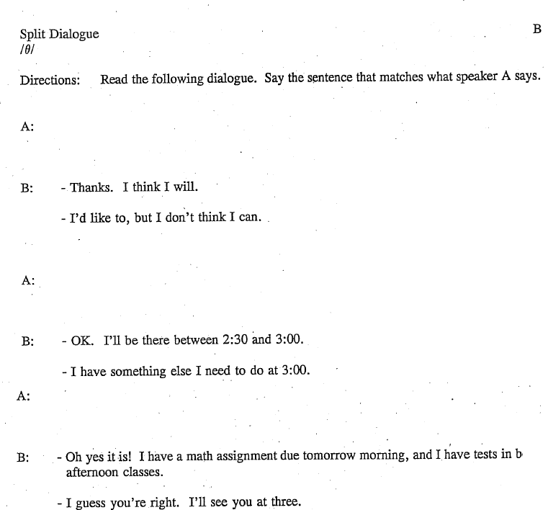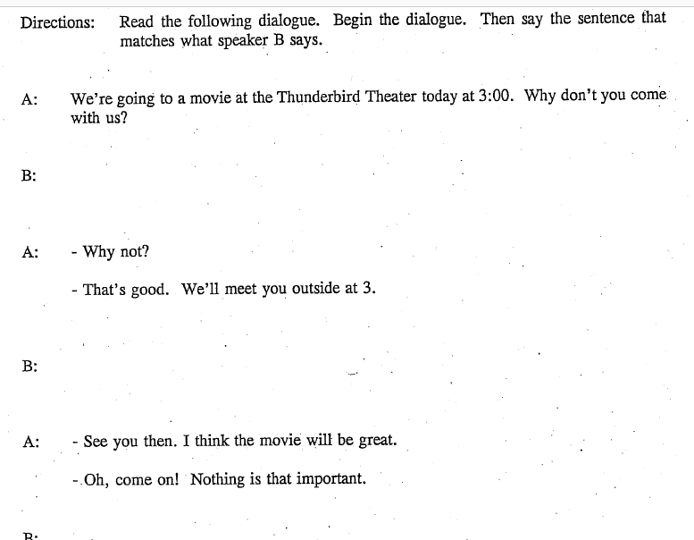

3. Role Play Good communicative exercise, we had a short conversation and it was good for practicing the sound. After all the exercises I concluded that it gets better as we move on with exercises but she’s still struggling with producing the sound when it comes at the end. I put the emphasis on it because she’s not able to pronounce the sound in that environment no matter how hard she tries. Next class, I will try to work on that a little bit more.
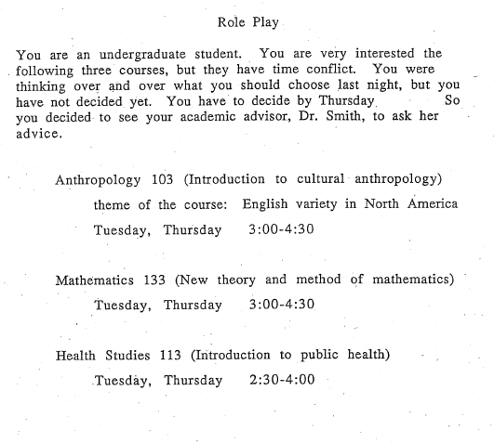

WEEK THREE (Full Phrase Rhythm)

Ear Training and Review
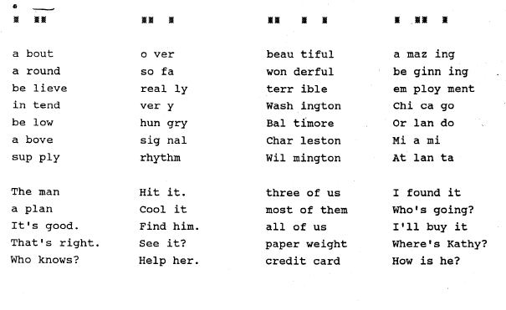
- Identify the stress pattern This section tests phrase rhythm. Listen for the reduced vowels in the underlined words. Pay attention to the underlined words, they use a reduced vowel. An exercise from the diagnostics to check if she’s having any progress, and she does have some progress in terms of stressing the content words, but she doesn’t reduce the function words

1. Do you like bread and butter?
2. I tried out for the team.
3. Have you been to New York?
4. I had to either stay or go.

5. I used to work on a farm.
6. Have you ever flown on a plane?
7. He said that he can be there.
8. I used to drive everywhere in a truck.

Production
1. Riddles
Fun and interesting exercise. I read the riddles first as a model and she tried to pronounce them correctly. I must say she was struggling with it because she’s not very fluent and this was a problem for her.
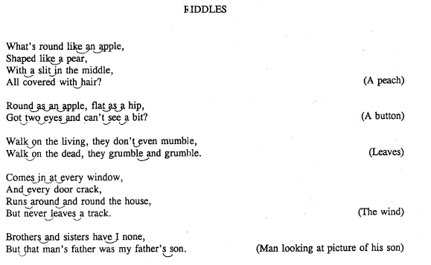

We took a look at the table and I read and compared the way learners of English speak at the beginning, careful good pronunciation of words and the actual way American people speak. She enjoyed the exercise and said that this is very useful for her
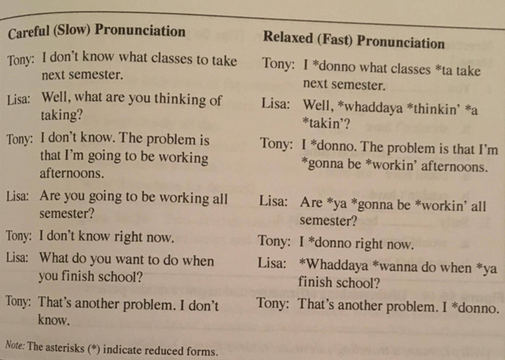
3. Reading I had planned for a communicative exercise here but we ran out of time. Anyway, it wasn’t that important because we covered everything that I planned. At the end I asked if she has any comments or questions and she commented on the last exercises. She said it’s an amazing thing for her to be aware of this feature and it will be very helpful in perception of American speech, but stated that it seems to difficult for her to produce the reduced vowels and the connected speech.
