Pronunciation Tutoring Reflections
Assignment Description

In the pronunciation tutoring project, you will diagnose the pronunciation of an English learner, plan and prepare teaching materials, and teach four 50-60 minute sessions over four weeks. After each tutoring, prepare a report/reflection of the tutoring to turn in. It should include the following items.

- A description of how the tutoring proceeded.
  - What happened?
  - What order did you teach the items in and why?
  - What did you notice about the tutee’s performance in perception and production?

I meet my tutee at the library in the Group Study room again. We needed to cancel the previous week’s meeting and we met on a Monday at the beginning of the Third week. We started with casual conversation to create relaxed atmosphere and I noticed some improvement in her pronunciation of the ‘th’ sound. She stated that now that she is aware of he
r problems she pays more attention on native speakers’ speech and tries to use those features in her own speech.
I continued with the same order. I started with the segmental, /ɛ/- /ey/ distinction, followed by /θ/ - /s/ with focus on distinguishing /s/, and finally we finished the lesson with Rhythm exercises, focusing on the difference between stressed and unstressed words.
My tutee’s performance in terms of perception is by far improved in all of the targets. She did not get all of the sounds and asked me to repeat a few times, but she is improving rapidly because at the beginning she could hear the difference at all. In terms of production, she is doing a great job with the first target /ɛ/- /ey/, she has improved a lot in the second target /θ/ - /s/ (she rarely uses the sound /s/ instead of /θ/, and in the last target, she still struggles with getting the right stress when reading, but I believe this is mostly due to her lack of knowledge of the English language in general and insecurity in the production.

- A reflection and analysis of your own performance as a teacher.
  - What went well?
  - What did not go so well? Were they any exercises that didn’t work? Why?
  - What surprised you?
  - Were there things you did that you would change for next time? Explain what they were and why you would change them.
In general, everything went well. We have a great working atmosphere and the student is really hardworking and eager to learn. She is becoming more aware of her problems and that seems to help her a lot in production as well. This time, I covered almost all of the exercises I have planed, so time management was better this time. Maybe we covered the exercises more quickly because the student knew what we are working on, her performance was improved and the exercises were right on target. As for myself, I had more orientation on how long an exercise can take so I tried to plan accordingly.
I wasn’t surprised by anything today. I had a clear picture from the previous lesson about the student’s knowledge and the lesson went on smoothly. I may say I was slightly surprised from her improvement. According to our previous meeting I was expecting somewhat slower progress, but she seemed much better this time.
This time I included a communicative exercise. The exercise was planned to be more interactive and the student tried to answer the questions but she didn’t know what to say about topic. Maybe, I would choose a different topic more adapted to her interest that would boost her imagination and get her to speak more eagerly.

- Any questions that you would like us to address.

I would like to ask if the student’s proficiency can influence the student’s progress in pronunciation, especially when it comes to rhythm.

- Include your lesson plan for the week and the exercises you used. You may make comments on the exercises if it helps your analysis, or you may integrate your analysis, reflections, and exercises all together.

Remember, it is important to describe fully, but it is equally important to reflect and analyze your own performance as a teacher.

WEEK TWO (/ey/ - / ɛ/ focus on /ɛ/)
Review /ey/ Interesting exercise, I gave the student short instructions and she understood them. I was reading the questions and the student was giving me the response. She pronounced almost all of the /ey/ sounds correctly. Whenever she hesitated, it was mostly the words that she didn’t understand. I gave her some feedback on her production of the sound, but it was generally good.
- Transformation
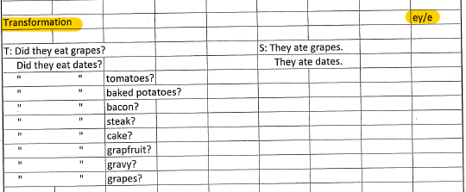
Ear Training /ɛ/
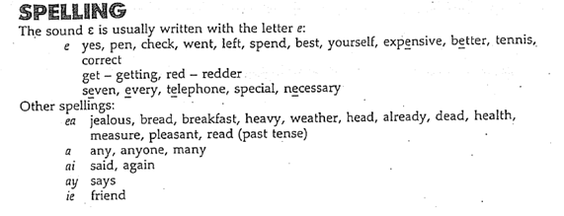
Short description of the sound and its spelling.
- Listen to the text and underline the /ɛ/ sound words
The purpose of this exercise was to get the student to recognize the sound in larger context and not only individual words. She underlined almost all of the words correctly. She had underlined some of the words that contain the /ey/ sound, but she corrected herself when reporting back to me.
- Word 1/Word 2 The student listened to the words and decided which words have the /ɛ/ sound. After that, she wanted to read all the words by herself and I allowed that because I wanted to see how much she will accomplish by herself. She made some mistakes but generally she was good.
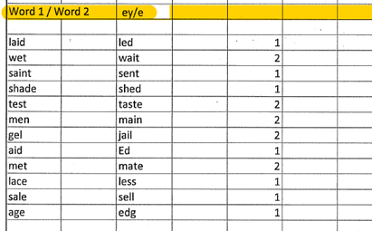
- Yes/No
Scale, game, less, vase, picture frame, sell, radio, met, led, wet, tape recorder Similar to the previous exercise but different words to check the perception of the sound.
Production
- Repeat Another controlled exercise, The student’s lengthened the /ɛ/ sound a little bit and I emphasized that when giving feedback.
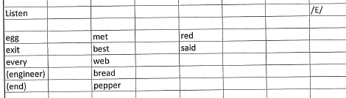
- Appropriate Response The student enjoyed this exercise and she did a great job. I praised her progress.
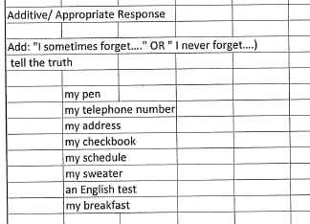
3. Conversation Planned to be a communicative exercises, however, the student did not know what to answer to my questions because maybe she did not like the topic. We took several turns, and the students production was good.
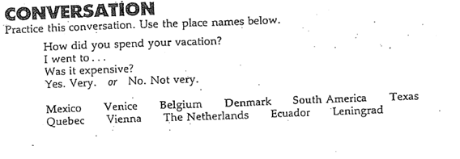

WEEK TWO (/θ/ - /s/)

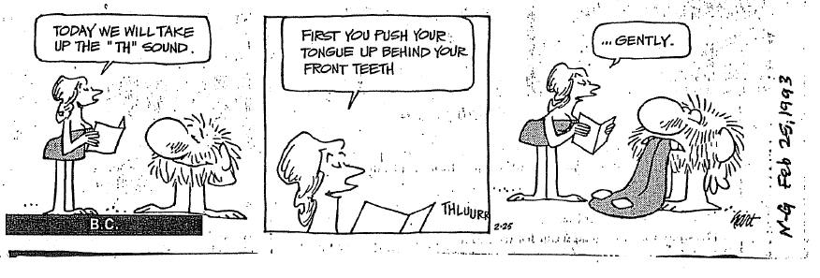

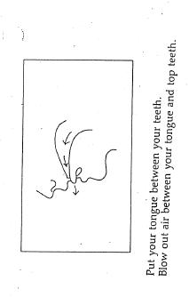
A short picture and explanation of the production of the /th/ sound. I used the funny strip to bring in some humor and by doing that to make the student remember the place and manner of articulation of this sound

Ear Training
- Listen controlled exercise – the student had problems in production occasionally, when the sound was at the end of the word, and when the /th/ sound and /s/ sound were next to each other like in Roths’ and moths
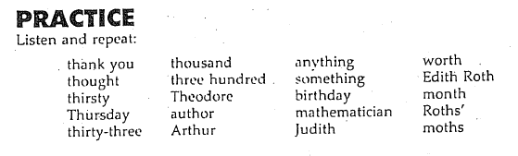
- Word 1/Word 2
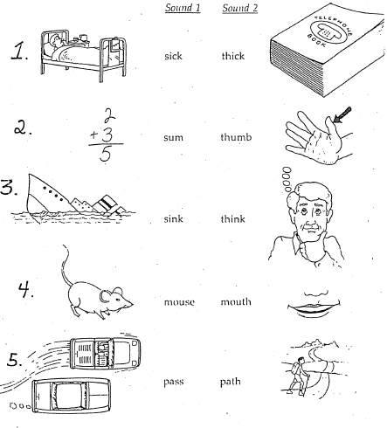
3. Which word belongs to column A and which belongs to column B?
The student did not see the list of words, because in that way she was relying on spelling, which is easily distinguished in this case. I read the words and she decided and wrote the words in the right column without seeing the spelling.
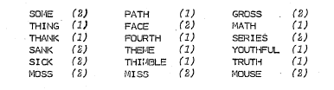

Production
- Repeat the word with /s/ (from e.2) No problems with this sound

2. Dialogue We took turns and read both roles. Her improvement is visible at this stage.
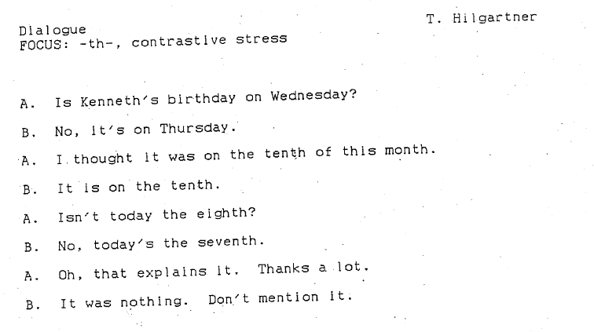
3. Word Association interesting exercise, we enjoyed it and had fun.
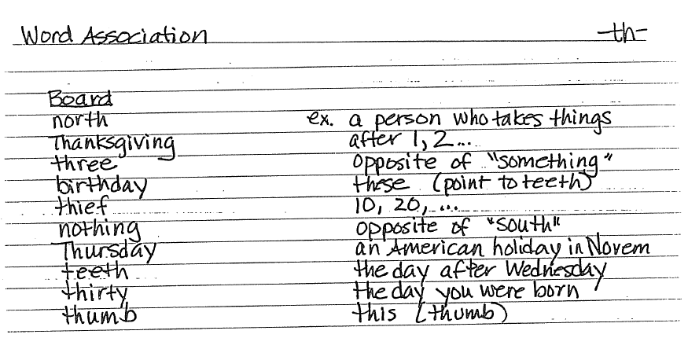
4.

WEEK TWO (Stressed VS Unstressed Words)
Short description about the notion of Rhythm
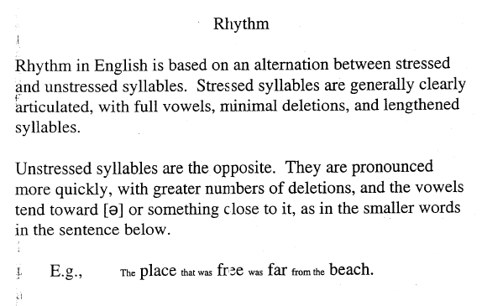
Review and Ear Training
- Identify the content words I took this dialogue again because we did not have enough time to work on some parts which I wanted to cover the previous time. She identified the content words easily but struggled in production. I explained the way she can practice and to try to read the dialogue in a more relaxed manner, as if we were acting it for a play. I saw some progress after the explanation
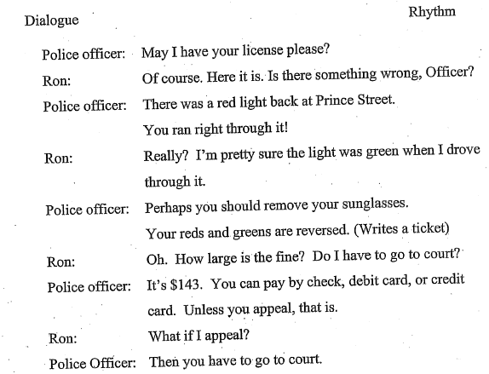
2. Lengthening: Stand up on stresses

Production
1. Repeat
2. Backward buildup Sentences from e.1 Very useful exercise, seemed to help the student to keep the content words stressed and to reduce the unstressed words.
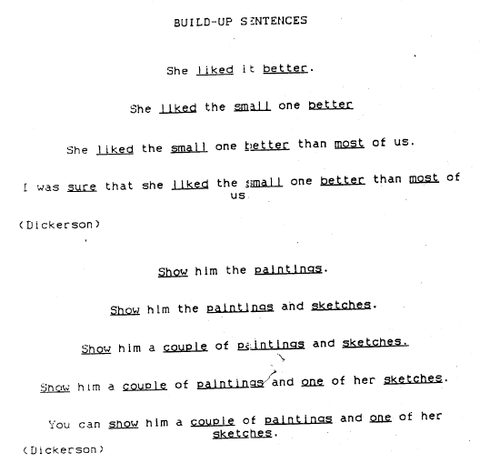
3. Shadowing
3. Role Play The student enjoyed this exercise but she did not do a very good job when it comes to pronunciation. Her function words were not linked and her content words were not always correctly emphasized. I gave her a short explanation, and she improved a little bit the second time.
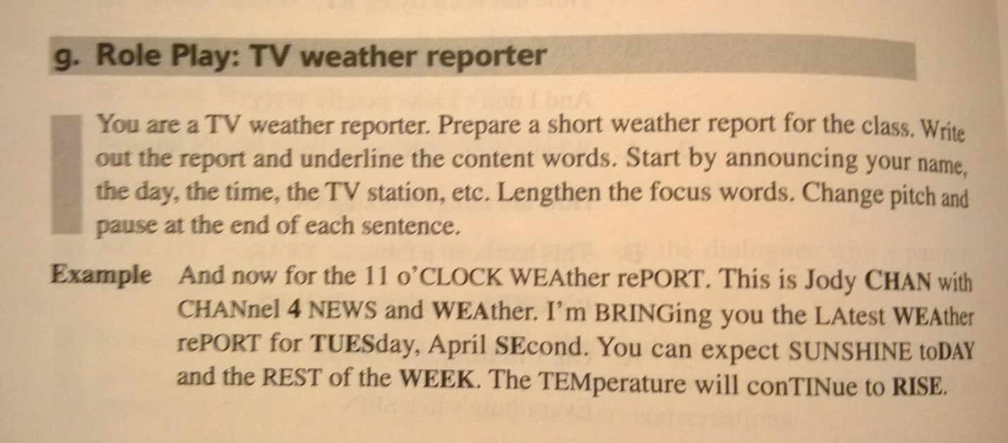

4. Jazz Chant
We enjoyed this exercise. It was a fun activity and it allowed the student to follow an easy pattern. The progress here is going slowly, but we are moving forward.

At the end of the class we had a short discussion on how she feels about her progress. She stated that she still feels uncomfortable speaking to other students but mainly because she believes that her vocabulary is limited. I explained that the process of learning a language starts by listening and understanding the language and that speaking will become easier with her constant exposure to the language. I encouraged her to listen to American TV shows and to try to communicate with her friends and use the language more frequently. I gave some personal examples on the issue which she seemed to like a lot. Sharing a similar experience made her feel more comfortable in speaking English to me. I analyzed her speech while chatting and she was doing a good job regarding our targets once she became more comfortable and wasn’t even thinking about the sounds. I am generally satisfied with the lesson and my student seemed satisfied too.

