Pronunciation Tutoring Reflections
Assignment Description

In the pronunciation tutoring project, you will diagnose the pronunciation of an English learner, plan and prepare teaching materials, and teach four 50-60 minute sessions over four weeks. After each tutoring, prepare a report/reflection of the tutoring to turn in. It should include the following items.

- A description of how the tutoring proceeded.
  - What happened?
  - What order did you teach the items in and why?
  - What did you notice about the tutee’s performance in perception and production?
I meet my tutee at the library in the Group Study rooms. First we started talking about general topics to get to know each better. The student seems to have limited vocabulary, but she is eager and willing to learn. She stated that she sometimes has problems understanding American speech because ‘they talk too fast’. Due to this fact, my plan is to bring in one ‘Connected speech’ exercise in our class, to demonstrate some of the shortenings that happen in speech, so that she will become aware of the way American people speak first, and then to try to produce it herself.

We started with segmental, /ɛ/- /ey/ distinction, with focus on /ey/. I decided to start with this feature because I think that this is one of the most important problems that cause unintelligibility in her speech. It turned out that the problem truly is serious and she wasn’t able to distinguish between those two sounds, so I dedicated more time on the Ear Training at this point, because it is most important for her to be able to recognize it first in order to use it. We did three exercises for Listening, and by the end of e.3 she started to notice the difference and her perception improved. After that she attempted to produce the words (repeat after me). It became better and better as we moved forward. I stopped at e.2 production. I planned for a communication exercise, but did not continue in favor of time I left that exercise for the next meeting.

We continued with /θ/ - /s/ with focus on /θ/. Also major problem for the student. At the beginning she struggled with perception and distinguishing between the two sounds. As she improved her perception, I explained the production and articulation of the sound /θ/ because even though she distinguished between the sounds she kept producing /s/. We did production exercises and we stopped at exercises 2. We continued with Word stress. This task was easier for her in terms of perception. She was able to recognize the stress, but when it came to production that was the more difficult part. We read the dialogue several times, and we stopped at e.2 in the production part.

- A reflection and analysis of your own performance as a teacher.
  - What went well?
  - What did not go so well? Were they any exercises that didn’t work? Why?
  - What surprised you?
  - Were there things you did that you would change for next time? Explain what they were and why you would change them.

In general everything went well. The student felt comfortable, eager to learn and willing to cooperate. The exercises I planned were just the right ones. The only things that did not went according to my plan is the amount of exercises covered. I planned for more exercises, I will send the original plan and I mentioned above how far we got. This was our first lesson so I did not know how much time the exercises will take and I wanted to plan for more. I will transfer the exercises that we did not cover in my next week lesson plan. The targets are well chosen and the student has some real problems with the perception and production of the segmentals and production problem with the suprasegmental.

- Any questions that you would like us to address.

How can I decide how much time an exercise will take, and is the amount of exercises important? Is it better to go over some things that are problematic and spend more time there or to move on to the next exercise and pay more attention to the particular problem in our next lesson?

- Include your lesson plan for the week and the exercises you used. You may make comments on the exercises if it helps your analysis, or you may integrate your analysis, reflections, and exercises all together.

Remember, it is important to describe fully, but it is equally important to reflect and analyze your own performance as a teacher.

*The exercises in Red are those that we did not cover

/ɛ/- /ey/-/ɪ/

WEEK ONE (Focus on /ey/)
Ear Training
1. Listen
2. Minimal pairs/ Circle the word you hear At this point the student struggled with distinguishing the two sounds, I explained the difference in production and emphasized the difference they create in meaning

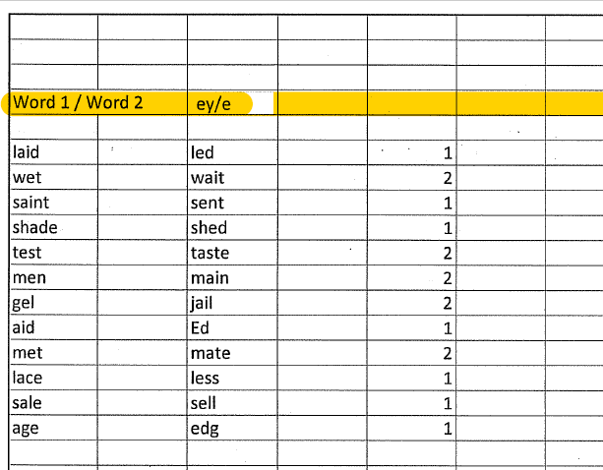

3. Yes/No /ey/ Student started recognizing the difference and answered almost all of the questions correctly
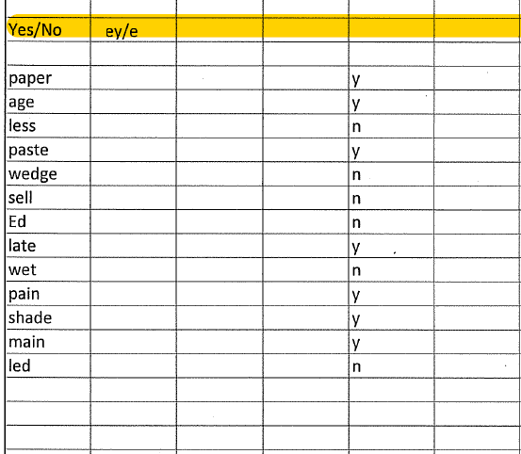

Production
- Repeat
/ Ey/ Words from e.2 Student has progress in pronunciation

Laid, wait, saint, shade, taste, main, jail, aid, mate, lace, sale, age

- Text [I read the text two times. The first time she underlines the /ey/ words; the second time she underlines the /ɛ/ words.]
Directions: Underline the words that will have the /ey/ sound in the following passage. Listen again, This time underline the words that will have the /ɛ/ sound in the following passage. Then practice reading it out loud. Student demonstrated progress by recongnizing most of the words, then by producing them correctly
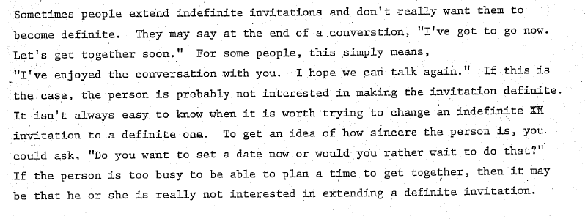
- Communicative task Did not cover*
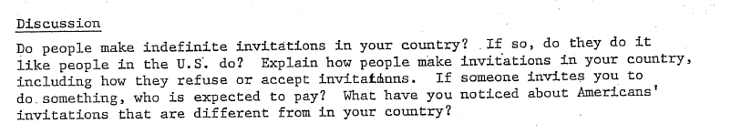

Th /θ/ - /s/

WEEK ONE (Focus on /(θ /)

Ear Training
1. Listen Student struggled with distinguishing the two sounds
2. Word 1/Word 2 I explained the difference in production and she attempted to produce the th- sound. She guessed most of the words but not all of them
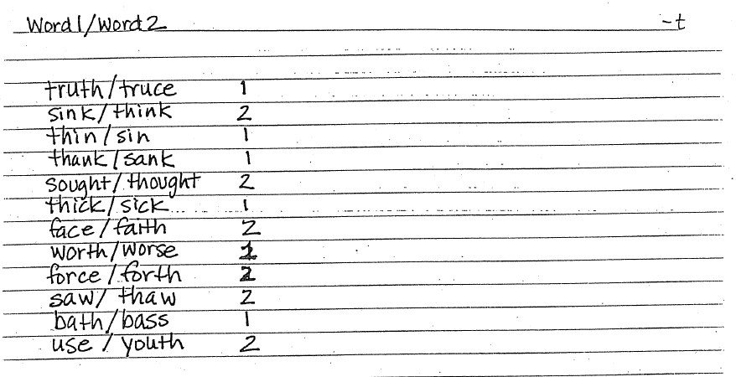
3. Repeat the word with /θ / (from the list above) Student attempted to produce the words with the target sound. We had some progress but we’re not there yet. She still mixes /s/ and /θ /
4. Yes/No ( I read one of the word pairs above and she needs to guess which word has the sound /θ/ Progress, student recognized most of the words

Production
- Repeat I explained the articulation of the sound again, student practiced the sound individually and then in the words tried to repeat after me, there was some progress but she still struggled to pronounce it correctly.
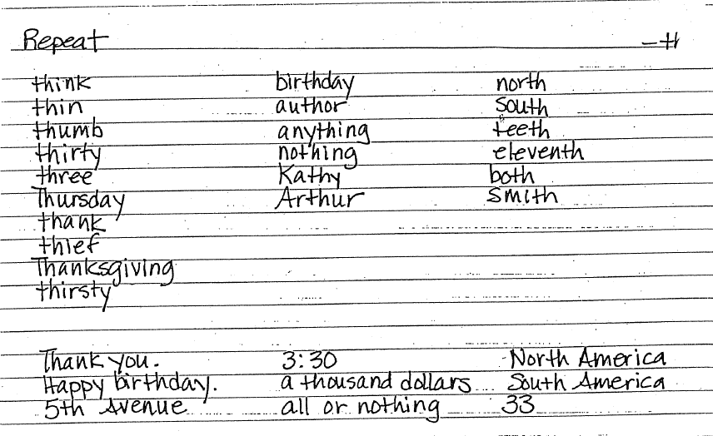

- Different words: First I read and she guesses, she reads the words and I guess Student could distinguish between sounds in perception and I praised her progress.
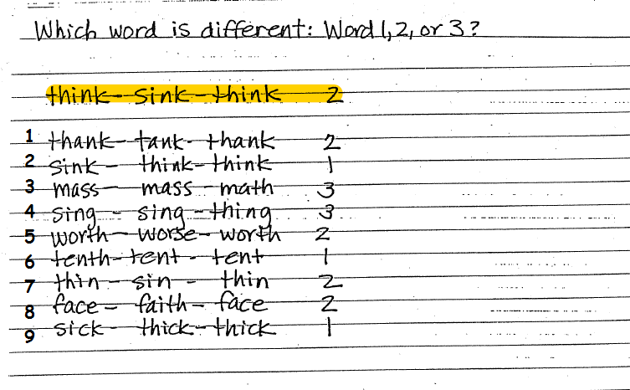
- Dialogue Not covered
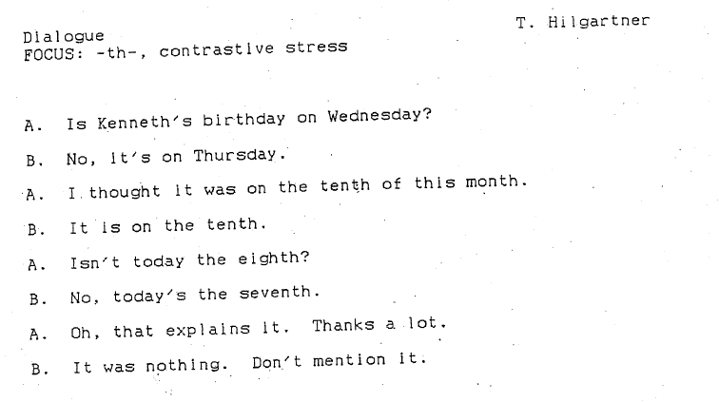

- Communicative task Not covered
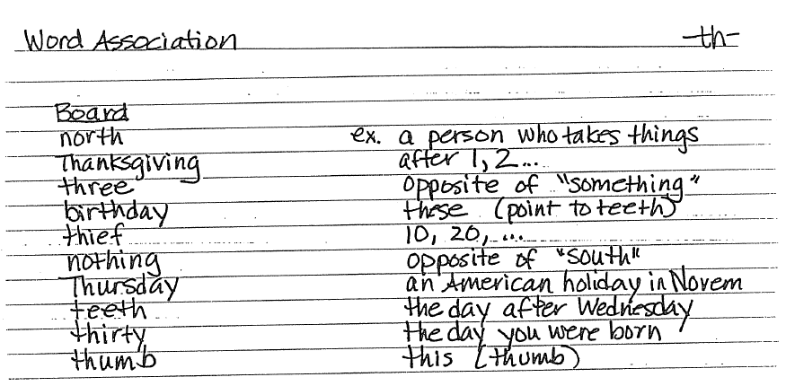

Stressed Words

Awareness and Ear Training
- Which syllable is stressed? I explained the notion of stress and the way she can recognize it. Student marked most of the words correctly.
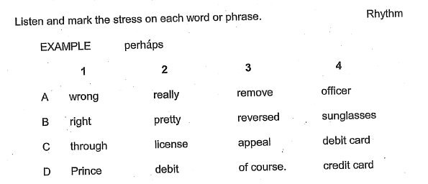
- Which word in the phrase is stressed? I explained the way English uses stress on a sentence level. Student explained that in her native language the rhythm in the sentence is not that obvious as in the English and pointed out that fact as her possible problem for not producing it correctly. She was aware of that and she recognized most of the stressed words in the sentence
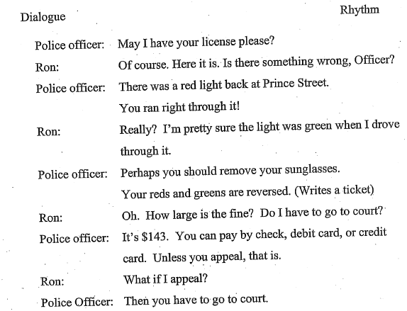

3. Word stress with rubber bands I explained the length of the stressed syllable and we practiced with the words from e.1. Helpful exercise

Production
1. Dialogue Student is aware of her problem but in production she doesn’t use it correctly. We changed roles two times so that she can hear how I used it and try to imitate, but the progress was slow.
2. Rule: CW lengthened, stressed * We stopped here due to lack of time, so I will use these exercises next time
3. Backward buildup*
4. Shadowing*

My first impression about the tutoring is that it is an interesting, challenging task and the process of learning goes slower than I expected. The Perception is more easily improved, but the production will need more lessons. The class was useful, it targeted the right problems and it was successful.

