Few days ago, I was scrolling down on Facebook News Feed and I came across this adorable young lady whose speech made me curious about the use of language. She said: “My mom was like ‘Hey Mila do you wanna hit the gym?’ I was like, who’s Jim? And what did he ever do to you?”
There are several things that can be analyzed here. First of all, the little girl hears the word ‘gym’ and she associates it with a word that is already known to her and she is confused. The words ‘gym’ and “Jim’ sound exactly the same and the little girl makes logical conclusion relying on her knowledge of the notion /ʤɪm/ or /jim/.
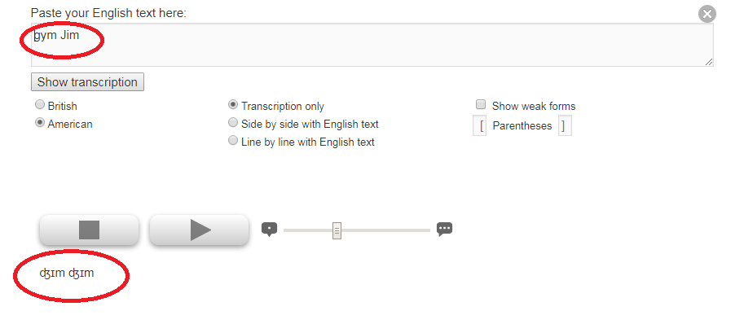
These words are called homonyms meaning that the words are pronounced the same but written differently. This semantic relationship is really interesting for analysis because of the confusion it may cause depending on the ‘definition’ the learner is familiar with. For example, the first time I heard the word bank in connotation with the river, I couldn’t connect my knowledge of the word with the context so I figured there must be another meaning of the word.
Furthermore the girl poses the question ‘What did he ever do to you?’. In this case, she relies on her knowledge of the word ‘hit’. She combines the two words that she’s familiar with and the sentence she hears is “Let’s hit Jim’. The verb ‘hit’ is used in a different connotation in this case. The phrase ‘To hit the gym’ means ‘To head to the gym to work out.’ There are a lot of collocations with the verb ‘hit’ and if one does not know the meaning could not understand the meaning of the utterance.
Finally, if we take a look at the phrase ‘I was like’ we can conclude that this is informal speech and the girl uses the phrase ‘like’ to introduce direct speech. I was like…/ he was like.. is followed by direct speech sentence. The formal version would be I said../He said.. followed by direct speech in quotation marks.

